**VISVESVARAYA TECHNOLOGICAL UNIVERSITY**

**“JnanaSangama”, Belgaum- 590014, Karnataka.**



**LAB REPORT**

**on**

**Machine Learning (23CS6PCMAL)**

***Submitted by***

**Likhith M (1BM22CS135)**

***in partial fulfillment for the award of the degree of***

**BACHELOR OF ENGINEERING**

***in***

**COMPUTER SCIENCE AND ENGINEERING**



**B.M.S. COLLEGE OF ENGINEERING**

**(Autonomous Institution under VTU)**

**BENGALURU - 560019**

**February 2025 – July 25**

**B.M.S. College of Engineering  
Bull Temple Road, Bangalore 560019**(Affiliated To Visvesvaraya Technological University, Belgaum)

**Department of Computer Science and Engineering**



**CERTIFICATE**

This is to certify that the Lab work entitled “Machine Learning (23CS6PCMAL)” carried out by **Likhith M (1BM22CS135),** who is bonafide student of **B.M.S. College of Engineering.** It is in partial fulfilment for the award of **Bachelor of Engineering in Computer Science and Engineering** of the Visvesvaraya Technological University, Belgaum. The Laboratory report has been approved as it satisfies the academic requirements in respect of an Machine Learning (23CS6PCMAL) work prescribed for the said degree.

|  |  |
| --- | --- |
| Sheetal V A  Assistant Professor  Department of CSE, BMSCE | Dr. Kavitha Sooda  Professor & HOD  Department of CSE, BMSCE |

**INDEX**

|  |  |  |  |
| --- | --- | --- | --- |
| **Sl.**  **No.** | **Date** | **Experiment Title** | **Page No.** |
| 1 | 03.03.25 | Write a python program to import and export data using pandas library functions. | 1 |
| 2 | 10.03.25 | Demonstrate various data pre-processing techniques for a given dataset. | 5 |
| 3 | 24.03.25 | Use an appropriate data set for building the decision tree (ID3) and apply this knowledge to classify a new sample. | 10 |
| 4 | 17.03.25 | Implement Linear and Multi-Linear Regression algorithm using appropriate dataset. | 14 |
| 5 | 24.03.25 | Build Logistic Regression Model for a given dataset. | 19 |
| 6 | 07.04.25 | Build KNN Classification model for a given dataset. | 23 |
| 7 | 21.04.25 | Build Support vector machine model for a given dataset. | 27 |
| 8 | 05.05.25 | Implement Random forest ensemble method on a given dataset. | 31 |
| 9 | 05.05.25 | Implement Boosting ensemble method on a given dataset. | 33 |
| 10 | 05.05.25 | Build k-Means algorithm to cluster a set of data stored in a .CSV file. | 36 |
| 11 | 05.05.25 | Implement Dimensionality reduction using Principle Component Analysis (PCA) method. | 42 |

Github Link: <https://github.com/01-BLUELOTUS/ML-1BM22CS135.git>

**LABORATORY PROGRAM – 1**

**Write a python program to import and export data using Pandas library functions**

OBSERVATION BOOK

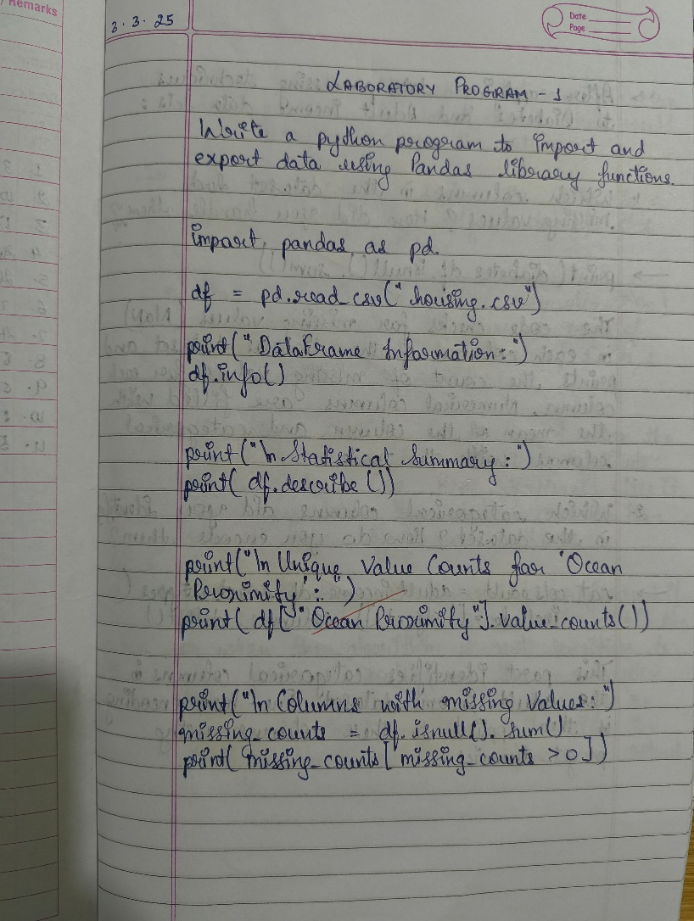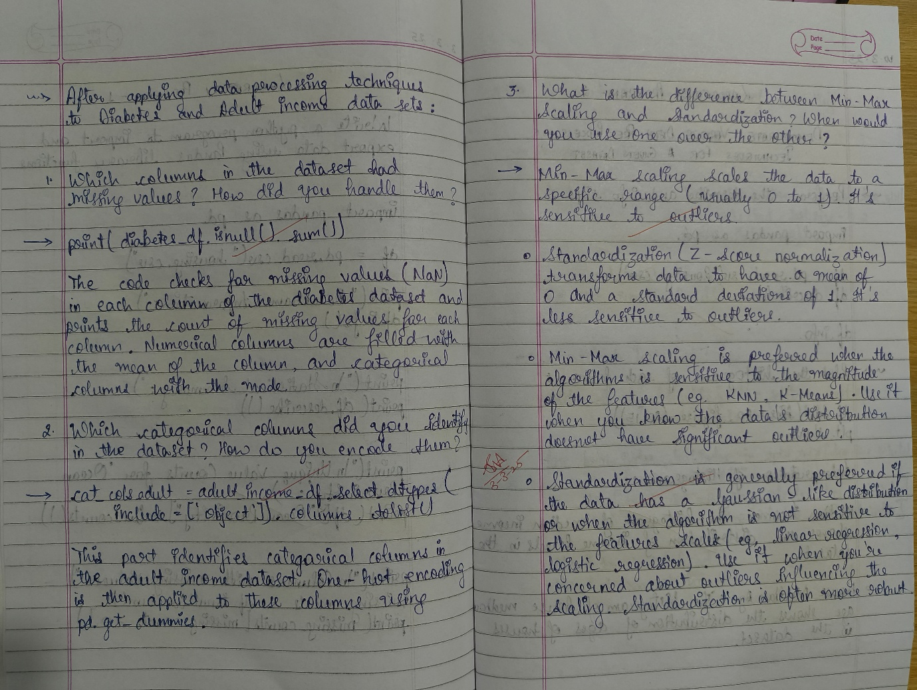

**CODE WITH OUTPUT**

**m**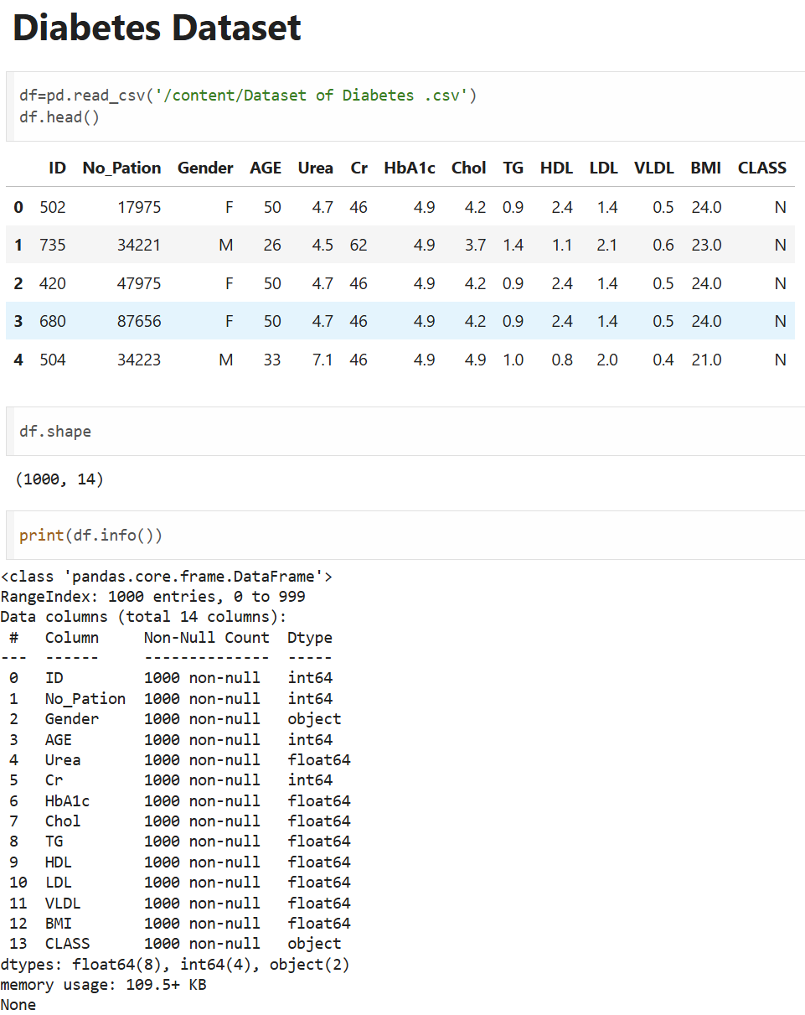

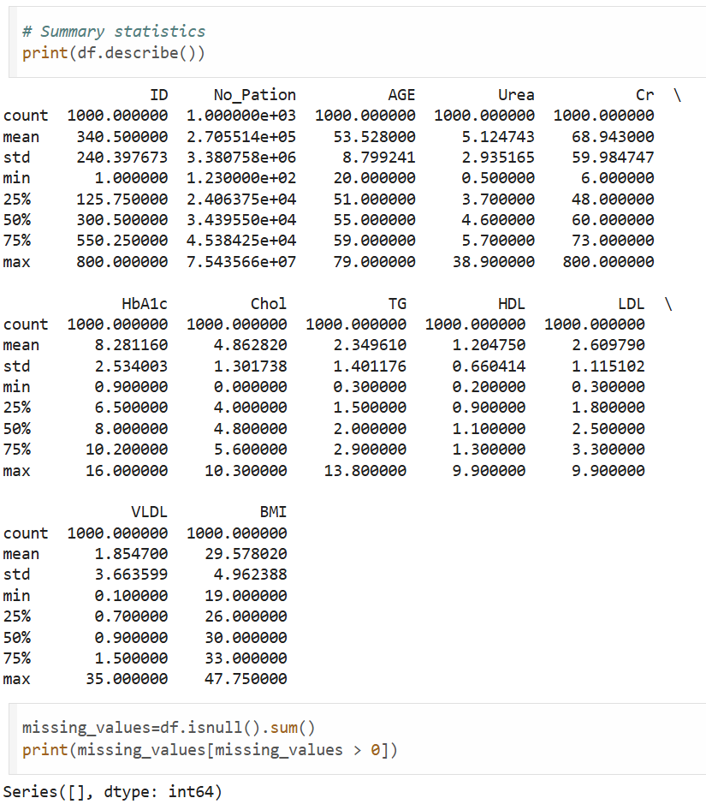

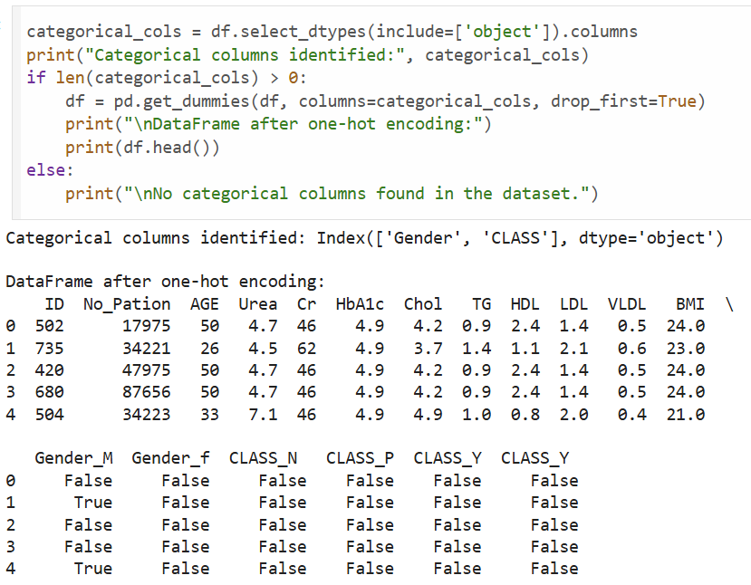

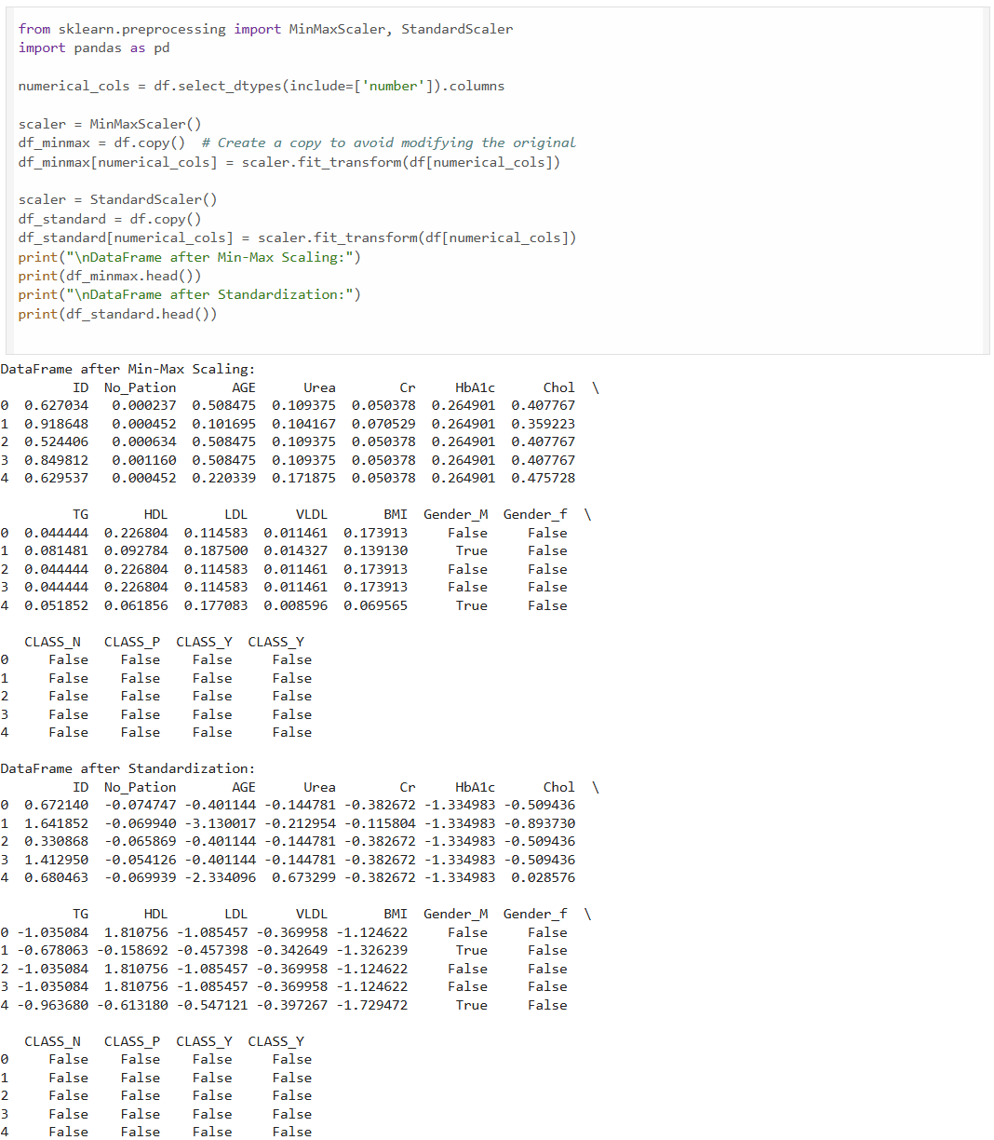

**LABORATORY PROGRAM – 2**

**Demonstrate various data pre-processing techniques for a given dataset**

OBSERVATION BOOK

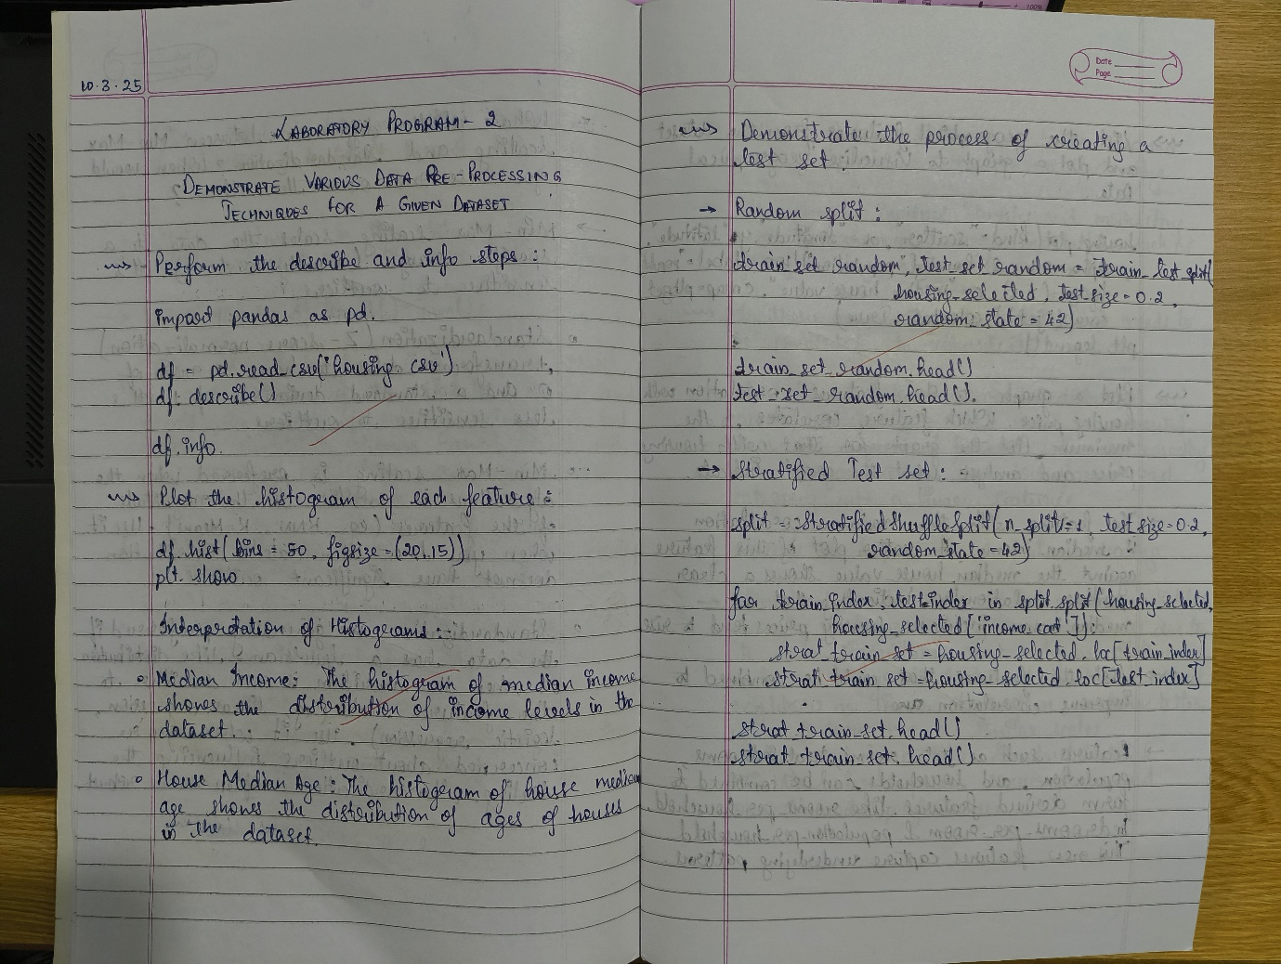

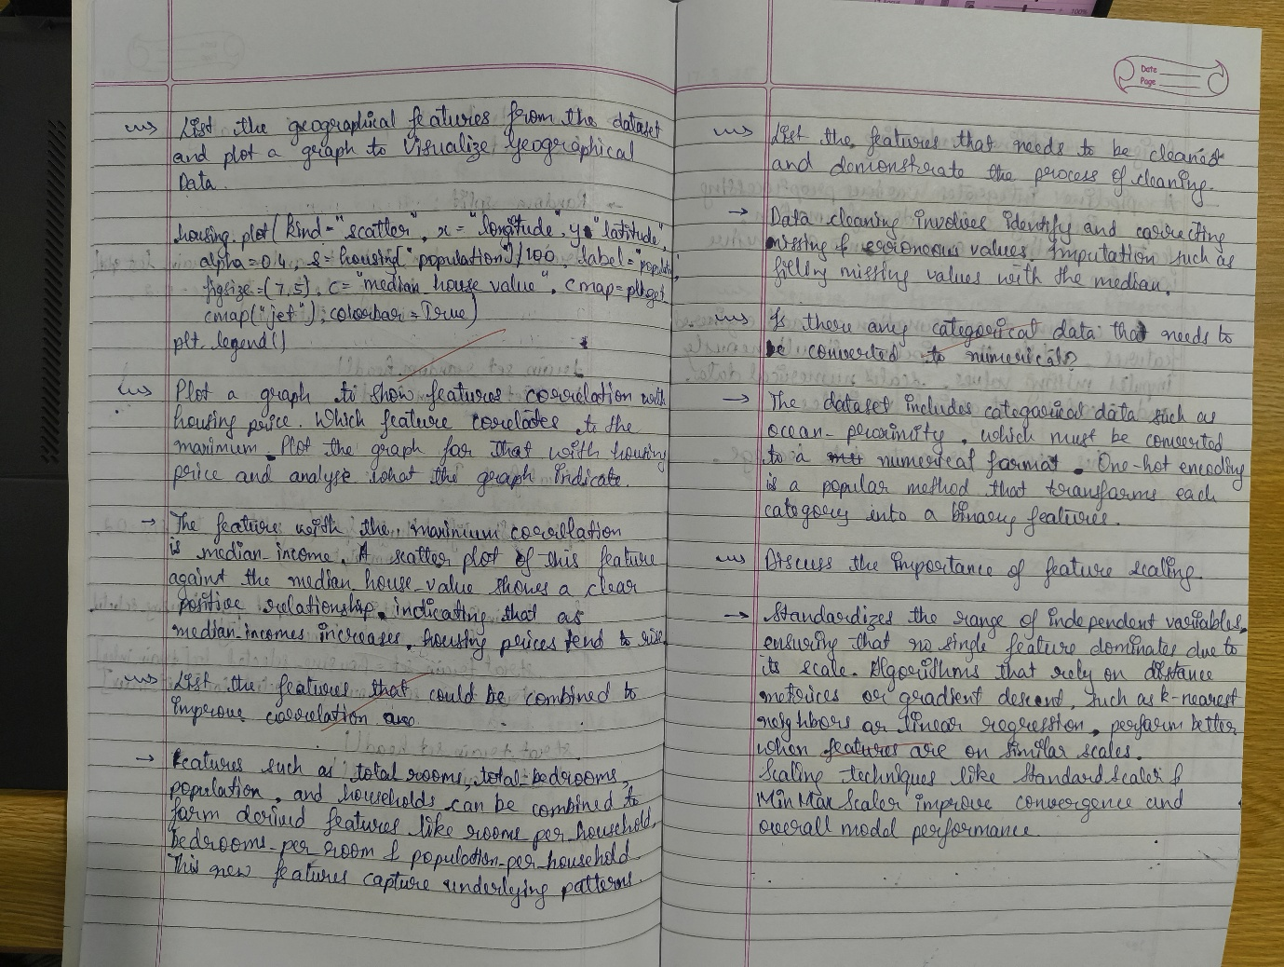

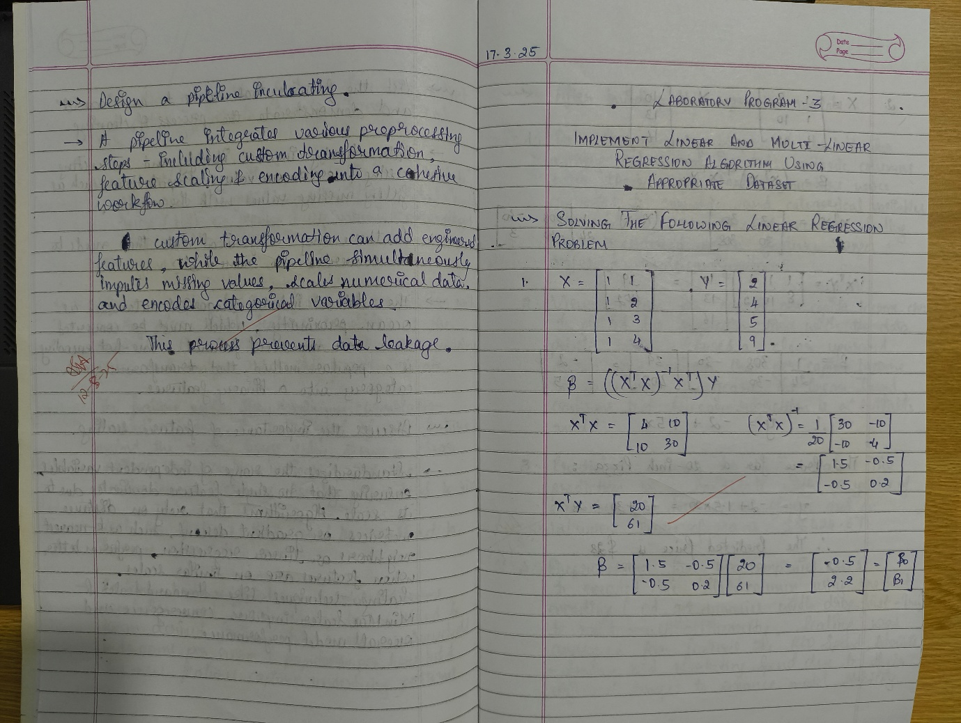

**CODE WITH OUTPUT**

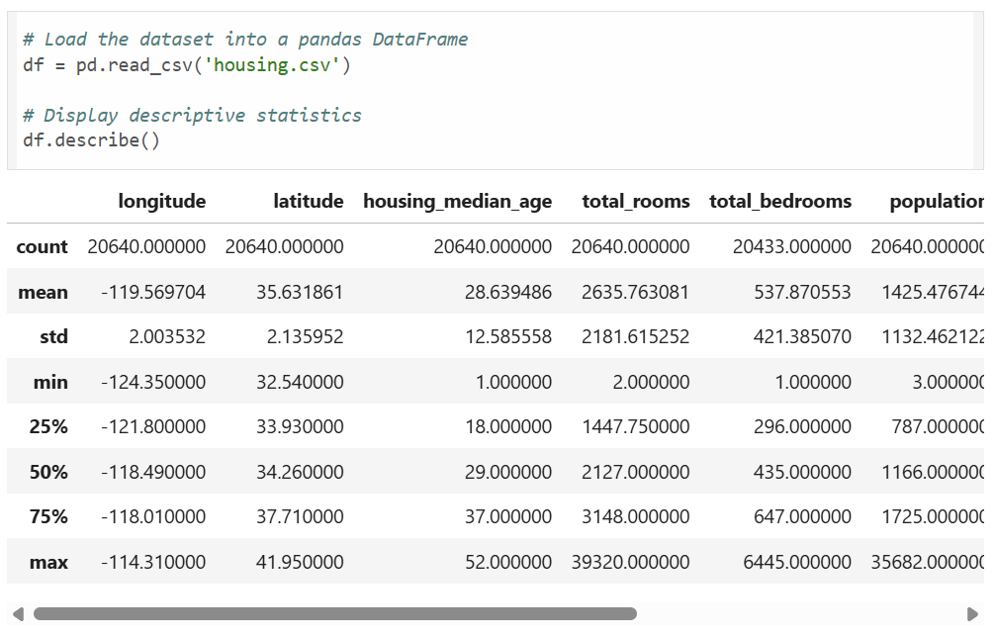

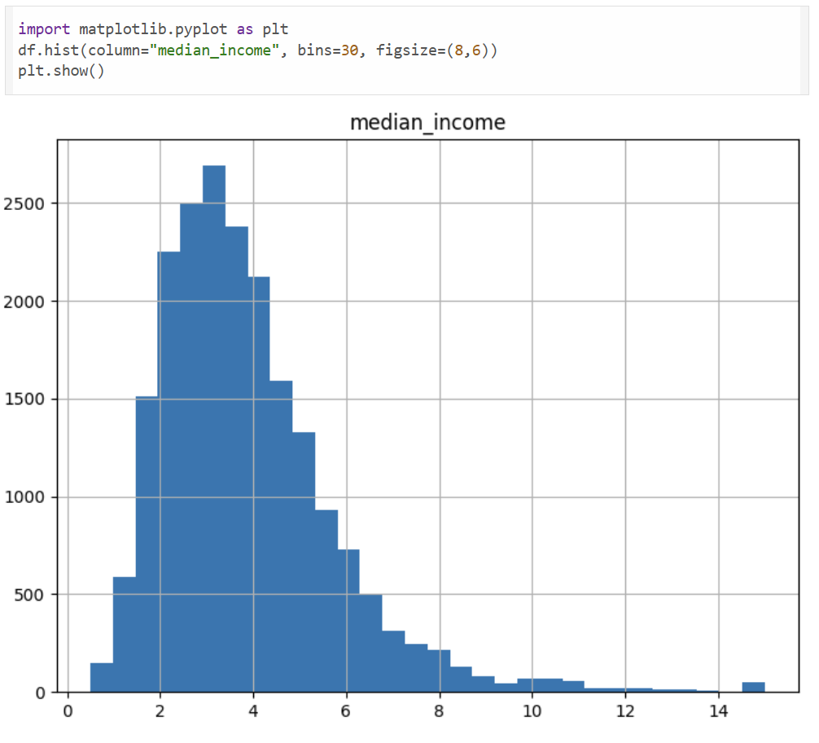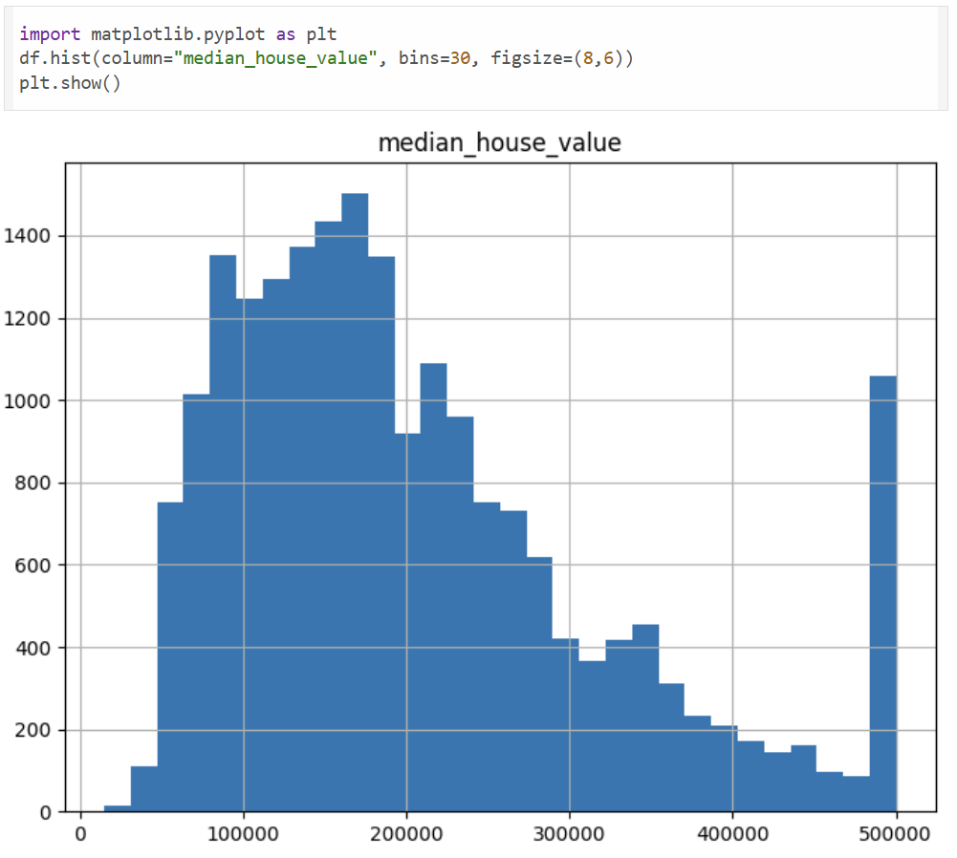

import pandas as pd

import numpy as np

from sklearn.model_selection import train_test_split, StratifiedShuffleSplit

*# Load the dataset*

housing = pd.read_csv('housing.csv')

*# For this demonstration, consider only 'median_income' and 'median_house_value'*

housing_selected = housing[['median_income', 'median_house_value']].copy()

*# Random split: This splits the data randomly without preserving any specific distribution.*

train_set_random, test_set_random = train_test_split(housing_selected, test_size=0.2, random_state=42)

*# For stratified sampling, first create an income category.*

housing_selected['income_cat'] = pd.cut(housing_selected['median_income'],

bins=[0., 1.5, 3.0, 4.5, 6., np.inf],

labels=[1, 2, 3, 4, 5])

*# Use StratifiedShuffleSplit to ensure the income distribution is preserved in both sets.*

split = StratifiedShuffleSplit(n_splits=1, test_size=0.2, random_state=42)

for train_index, test_index in split.split(housing_selected, housing_selected['income_cat']):

strat_train_set = housing_selected.loc[train_index]

strat_test_set = housing_selected.loc[test_index]

*# Remove the temporary income category attribute.*

for dataset in (strat_train_set, strat_test_set):

dataset.drop("income_cat", axis=1, inplace=True)

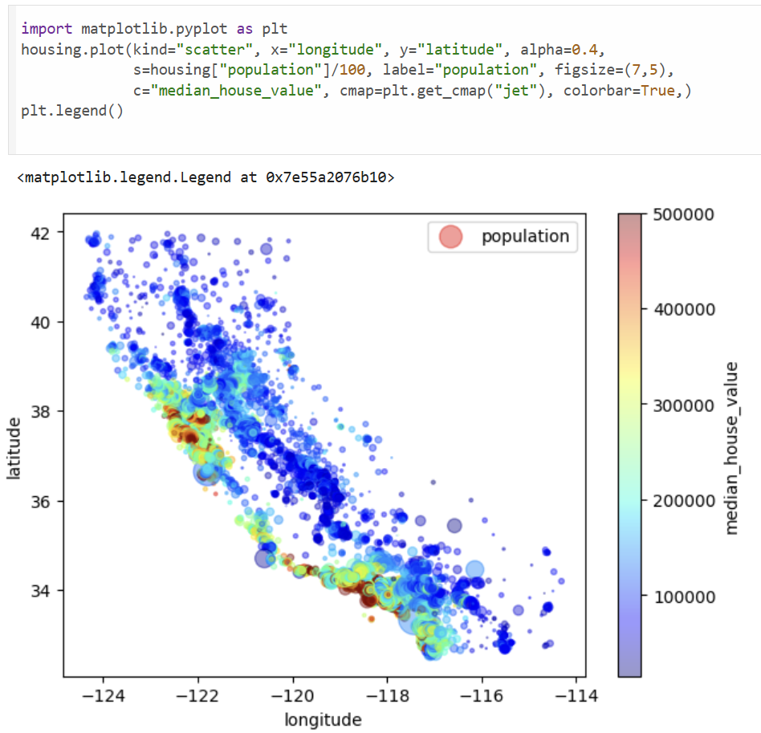

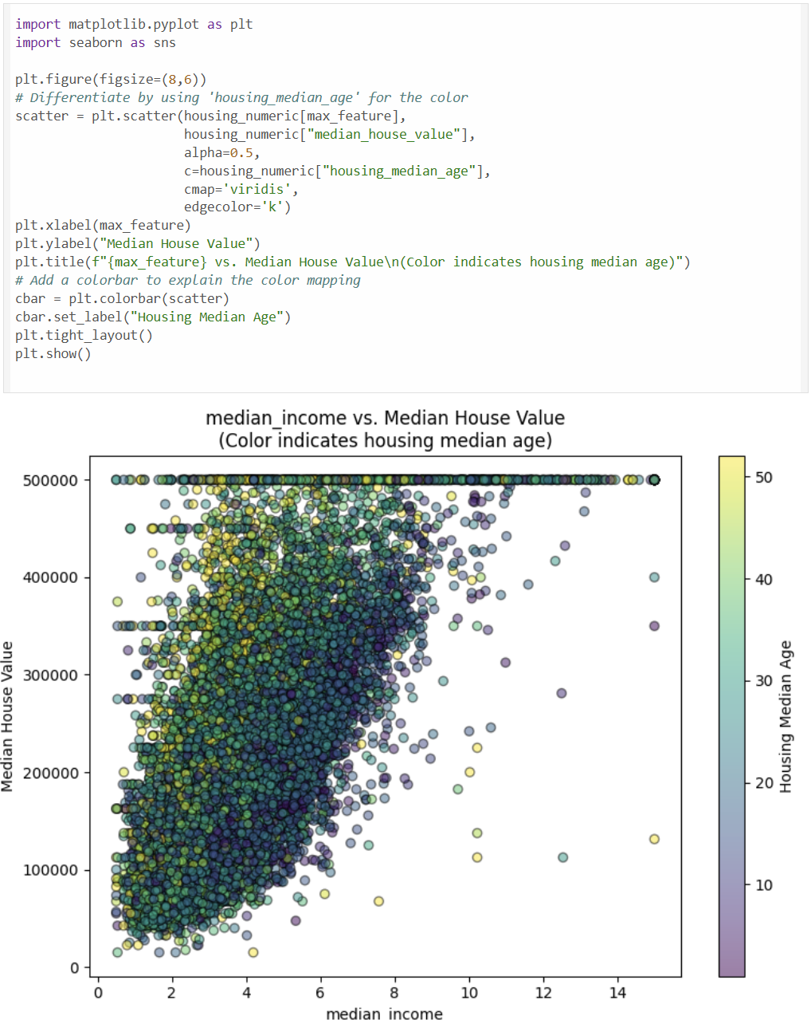

from sklearn.preprocessing import OneHotEncoder

*# Extract the categorical attribute*

housing_cat = housing[["ocean_proximity"]]

*# Perform one-hot encoding*

encoder = OneHotEncoder()

housing_cat_1hot = encoder.fit_transform(housing_cat).toarray()

*# Create a DataFrame for the encoded features*

housing_cat_1hot_df = pd.DataFrame(housing_cat_1hot,

columns=encoder.get_feature_names_out(["ocean_proximity"]))

housing_cat_1hot_df.head()

from sklearn.base import BaseEstimator, TransformerMixin

from sklearn.pipeline import Pipeline

from sklearn.compose import ColumnTransformer

from sklearn.preprocessing import StandardScaler

*# Custom transformer to add engineered attributes*

class CombinedAttributesAdder(BaseEstimator, TransformerMixin):

def __init__(self, add_bedrooms_per_room=True):

self.add_bedrooms_per_room = add_bedrooms_per_room

def fit(self, X, y=None):

return self

def transform(self, X):

*# Assumes X is a NumPy array with the following columns:*

*# total_rooms (index 3), total_bedrooms (index 2), population (index 4), households (index 5)*

rooms_per_household = X[:, 3] / X[:, 5]

population_per_household = X[:, 4] / X[:, 5]

if self.add_bedrooms_per_room:

bedrooms_per_room = X[:, 2] / X[:, 3]

return np.c_[X, rooms_per_household, population_per_household, bedrooms_per_room]

else:

return np.c_[X, rooms_per_household, population_per_household]

*# Identify numerical and categorical columns*

num_attribs = housing.drop("ocean_proximity", axis=1).columns *# All numeric columns*

cat_attribs = ["ocean_proximity"]

*# Build numerical pipeline: impute missing values, add new attributes, then scale*

num_pipeline = Pipeline([

('imputer', SimpleImputer(strategy="median")),

('attribs_adder', CombinedAttributesAdder()),

('std_scaler', StandardScaler()),

])

*# Build the full pipeline combining numerical and categorical processing*

full_pipeline = ColumnTransformer([

("num", num_pipeline, num_attribs),

("cat", OneHotEncoder(), cat_attribs),

])

*# Process the dataset using the pipeline*

housing_prepared = full_pipeline.fit_transform(housing)

print("Shape of processed data:", housing_prepared.shape)

**LABORATORY PROGRAM – 3**

**Use an appropriate data set for building the decision tree (ID3) and apply this knowledge to classify a new sample.**

OBSERVATION BOOK

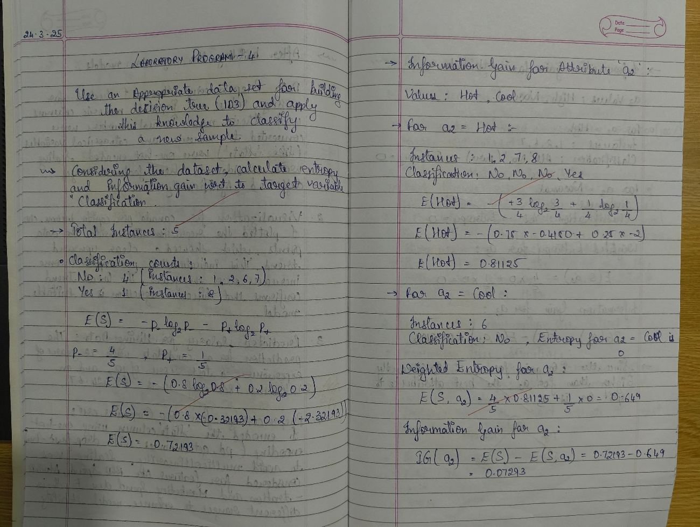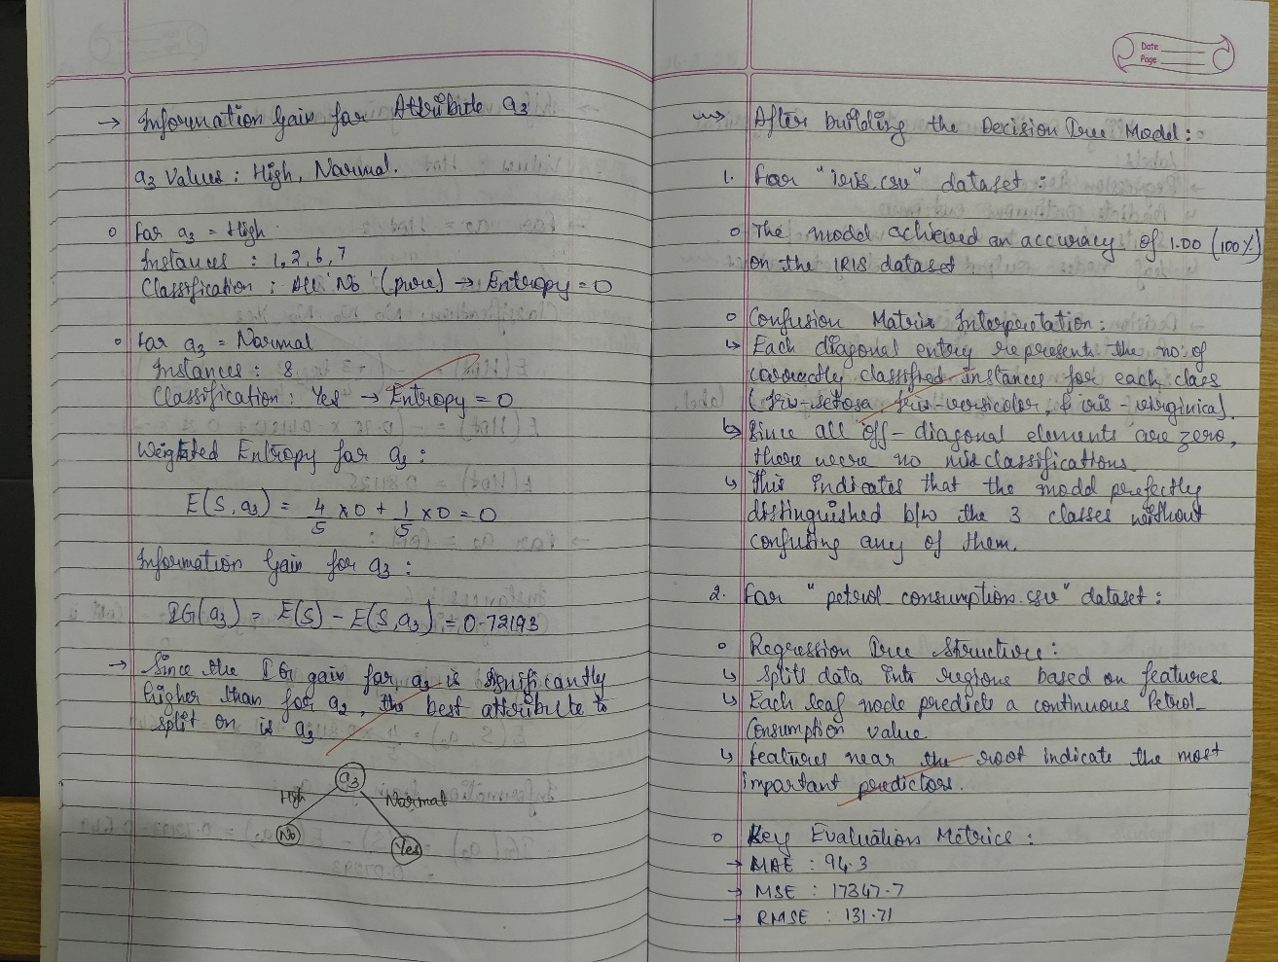

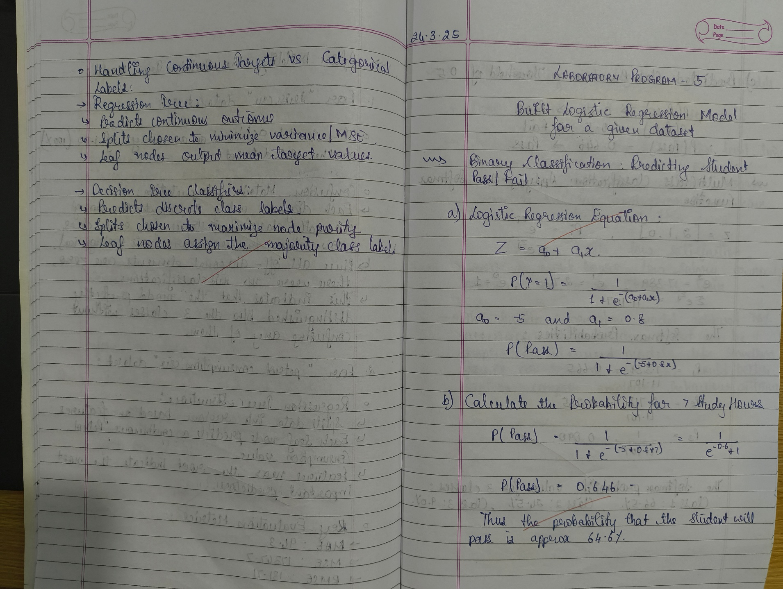

**CODE WITH OUTPUT**

import pandas as pd

from sklearn.model_selection import train_test_split

from sklearn.tree import DecisionTreeClassifier

from sklearn.metrics import accuracy_score, confusion_matrix, classification_report

import matplotlib.pyplot as plt

from sklearn.tree import plot_tree

*# Load the iris dataset (make sure iris.csv is in the working directory)*

iris = pd.read_csv("iris.csv")

*# Assuming the last column is the target (species) and the rest are features.*

X = iris.iloc[:, :-1]

y = iris.iloc[:, -1]

*# Split data into training and testing sets (80% training, 20% testing)*

X_train, X_test, y_train, y_test = train_test_split(X, y, test_size=0.2, random_state=42)

*# Initialize and train the Decision Tree classifier*

clf_iris = DecisionTreeClassifier(criterion='entropy', random_state=42)

clf_iris.fit(X_train, y_train)

*# Make predictions and evaluate the model*

y_pred_iris = clf_iris.predict(X_test)

accuracy_iris = accuracy_score(y_test, y_pred_iris)

conf_matrix_iris = confusion_matrix(y_test, y_pred_iris)

print("IRIS Dataset Decision Tree Classifier")

print("Accuracy:", accuracy_iris)

print("Confusion Matrix:\n", conf_matrix_iris)

print("Classification Report:\n", classification_report(y_test, y_pred_iris))

*# Visualize the decision tree*

plt.figure(figsize=(12, 8))

plot_tree(clf_iris, filled=True, feature_names=X.columns, class_names=clf_iris.classes_)

plt.title("Decision Tree for IRIS Dataset")

plt.show()

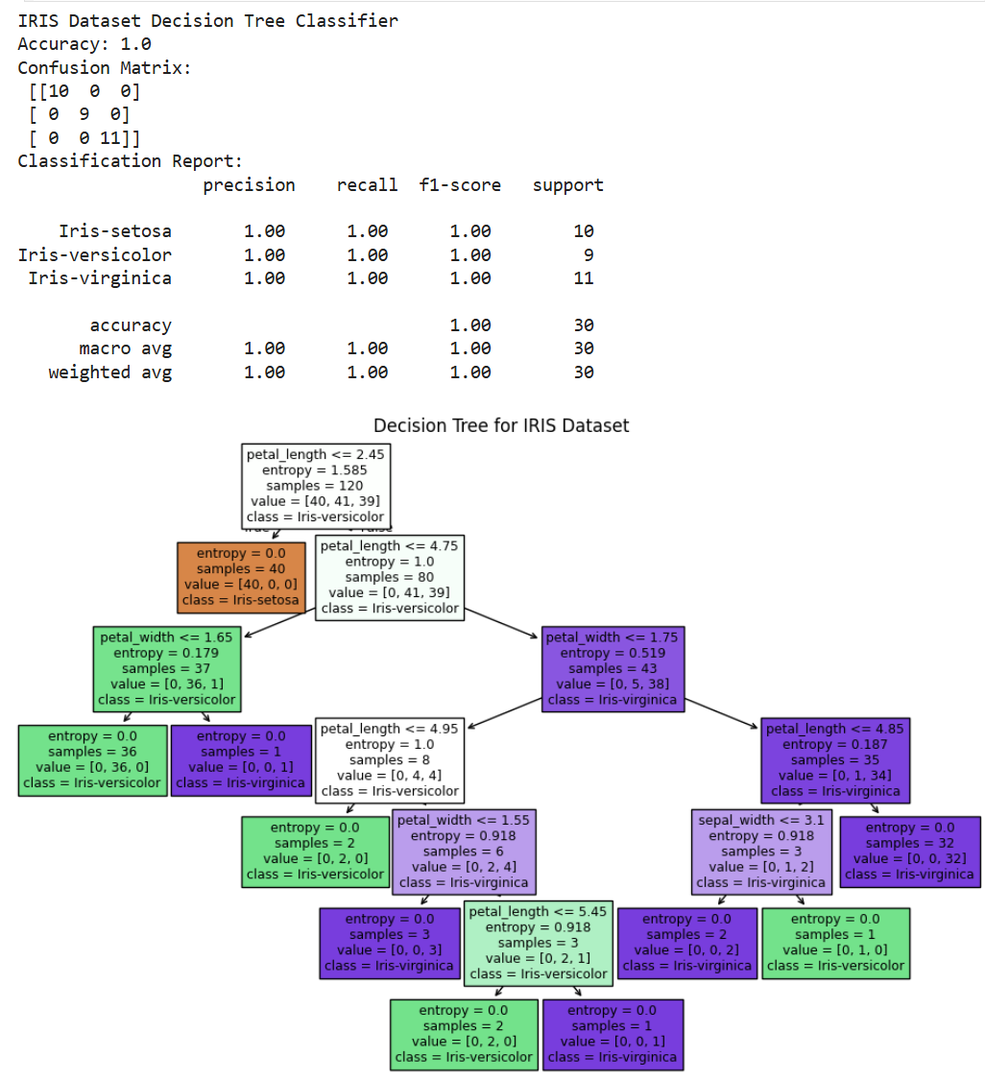

import pandas as pd

from sklearn.model_selection import train_test_split

from sklearn.tree import DecisionTreeClassifier

from sklearn.metrics import accuracy_score, confusion_matrix, classification_report

import matplotlib.pyplot as plt

from sklearn.tree import plot_tree

*# Load the drug dataset (make sure drug.csv is in the working directory)*

drug = pd.read_csv("drug.csv")

*# Since the target column is 'Drug', drop it from the features*

X_drug = drug.drop('Drug', axis=1)

y_drug = drug['Drug']

*# If there are categorical features, perform necessary encoding*

from sklearn.preprocessing import LabelEncoder

le = LabelEncoder()

*# Encode features that are categorical*

for col in X_drug.select_dtypes(include='object').columns:

X_drug[col] = le.fit_transform(X_drug[col])

*# Also encode the target variable if necessary*

y_drug = le.fit_transform(y_drug)

*# Split the data (80% training, 20% testing)*

X_train_d, X_test_d, y_train_d, y_test_d = train_test_split(X_drug, y_drug, test_size=0.2, random_state=42)

*# Initialize and train the Decision Tree classifier using entropy criterion*

clf_drug = DecisionTreeClassifier(criterion='entropy', random_state=42)

clf_drug.fit(X_train_d, y_train_d)

*# Make predictions and evaluate the model*

y_pred_drug = clf_drug.predict(X_test_d)

accuracy_drug = accuracy_score(y_test_d, y_pred_drug)

conf_matrix_drug = confusion_matrix(y_test_d, y_pred_drug)

print("Drug Dataset Decision Tree Classifier")

print("Accuracy:", accuracy_drug)

print("Confusion Matrix:\n", conf_matrix_drug)

print("Classification Report:\n", classification_report(y_test_d, y_pred_drug))

*# Visualize the decision tree*

plt.figure(figsize=(12, 8))

plot_tree(clf_drug, filled=True, feature_names=X_drug.columns,

class_names=[str(cls) for cls in clf_drug.classes_])

plt.title("Decision Tree for Drug Dataset")

plt.show()

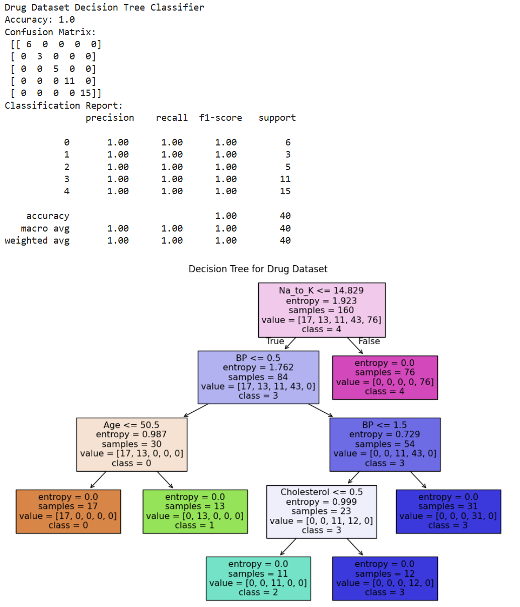

**LABORATORY PROGRAM – 4**

**Implement Linear and Multi-Linear Regression algorithm using appropriate dataset**

OBSERVATION BOOK

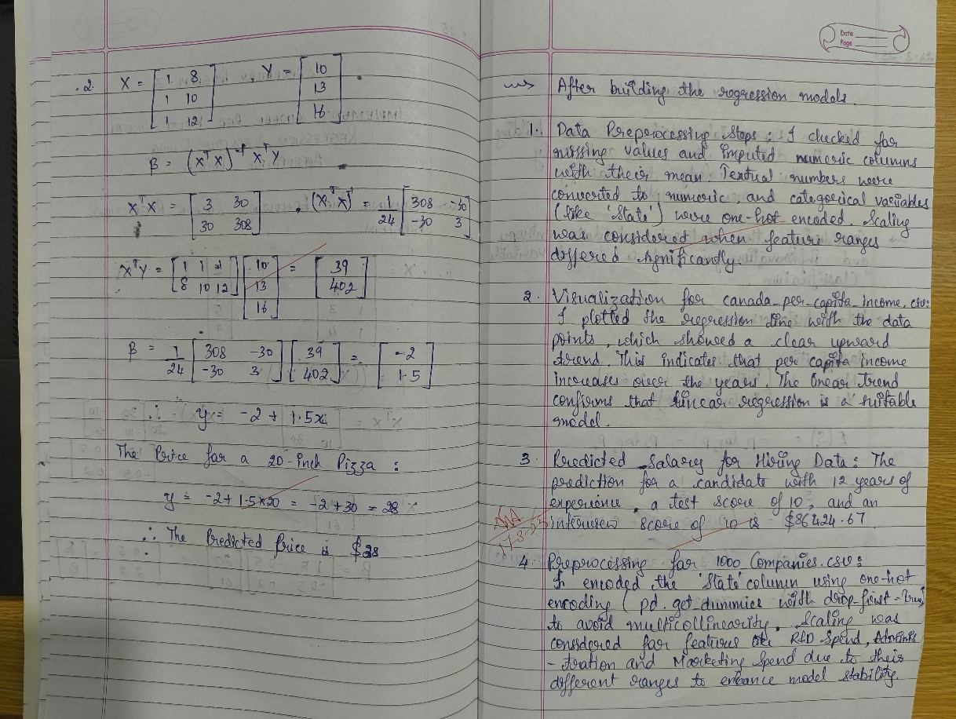

**CODE WITH OUTPUT**

*import pandas as pd*

*from sklearn.linear_model import LinearRegression*

*# Load the data*

income_data = pd.read_csv("canada_per_capita_income.csv")

*# Assumed data columns: 'Year' and 'PerCapitaIncome'*

print("Canada Income Data Head:")

print(income_data.head())  
*# Prepare feature and target*  
X_income = income_data[["year"]] *# Predictor variable: Year*  
y_income = income_data["per capita income (US$)"]  *# Build and train the linear regression model*  
model_income = LinearRegression()  
model_income.fit(X_income, y_income)

*# Predict per capita income for the year 2020*  
predicted_income = model_income.predict([[2020]])

print("\nPredicted per capita income for Canada in 2020:", predicted_income[0])

*# Plot the data points and the regression line*

plt.scatter(X_income, y_income, color='blue', label='Actual Data')

plt.plot(X_income, model_income.predict(X_income), color='red', label='Regression Line')

*# Plot the prediction for 2020*

plt.scatter(2020, predicted_income[0], color='green', label='Prediction for 2020')

*# Customize the plot*

plt.xlabel('Year')

plt.ylabel('Per Capita Income (US$)')

plt.title('Canada Per Capita Income Prediction')

plt.legend()

plt.grid(True)

*# Display the plot*

plt.show()

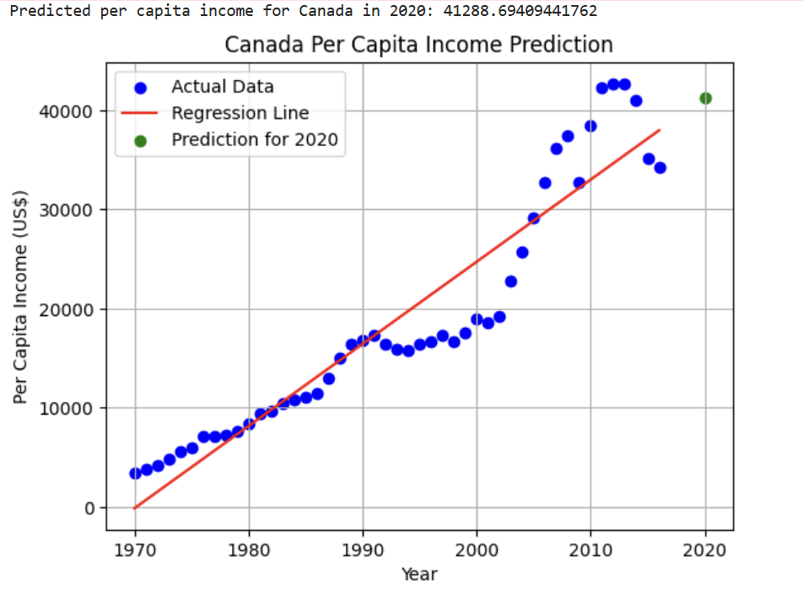

import numpy as np

import matplotlib.pyplot as plt

import pandas as pd

from sklearn.linear_model import LinearRegression

*# Load the salary data*

salary_data = pd.read_csv("salary.csv")

print(income_data.head())

*# Prepare feature and target*

X_salary = salary_data[["YearsExperience"]] *# Predictor variable: Years of Experience*

y_salary = salary_data["Salary"]

*# Build and train the linear regression model*

model_salary = LinearRegression()

model_salary.fit(X_salary, y_salary)

import matplotlib.pyplot as plt

*# Plot the data points and the regression line*

plt.scatter(X_salary, y_salary, color='blue', label='Actual Data')

plt.plot(X_salary, model_salary.predict(X_salary), color='red', label='Regression Line')

*# Plot the prediction for 12 years of experience*

plt.scatter(12, predicted_salary[0], color='green', label='Prediction for 12 years')

*# Customize the plot*

plt.xlabel('Years of Experience')

plt.ylabel('Salary')

plt.title('Salary Prediction based on Experience')

plt.legend()

plt.grid(True)

*# Display the plot*

plt.show()



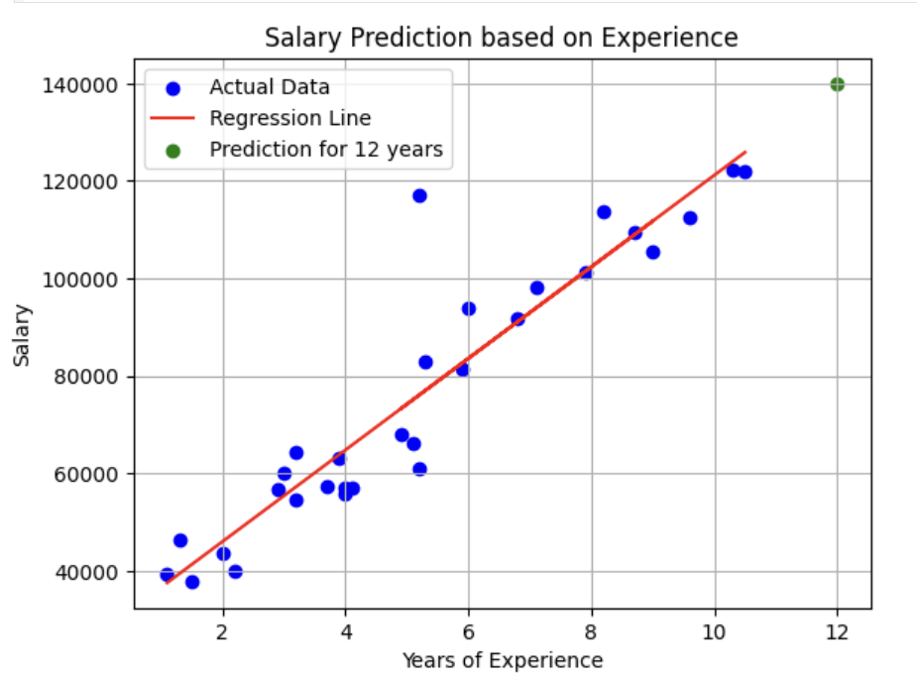

import pandas as pd

import numpy as np

from sklearn.linear_model import LinearRegression

*# Read the CSV file (ensure the file is uploaded in your Colab environment)*

df = pd.read_csv("hiring.csv")

*# Rename columns for convenience*

df.columns = ['experience', 'test_score', 'interview_score', 'salary']

print("Original Data:")

print(df)

*# Function to convert experience values to numeric*

def convert_experience(x):

try:

return float(x)

except:

x_lower = str(x).strip().lower()

return num_map.get(x_lower, np.nan)

*# Convert the 'experience' column using the mapping*

df['experience'] = df['experience'].apply(convert_experience)

*# Convert 'test_score', 'interview_score', and 'salary' to numeric (coerce errors to NaN)*

df['test_score'] = pd.to_numeric(df['test_score'], errors='coerce')

df['interview_score'] = pd.to_numeric(df['interview_score'], errors='coerce')

df['salary'] = pd.to_numeric(df['salary'], errors='coerce')

print("\nData After Conversion:")

print(df)

*# Fill missing values in numeric columns using the column mean*

df['experience'].fillna(df['experience'].mean(), inplace=True)

df['test_score'].fillna(df['test_score'].mean(), inplace=True)

df['interview_score'].fillna(df['interview_score'].mean(), inplace=True)

print("\nData After Filling Missing Values:")

print(df)

*# Prepare the feature matrix X and target vector y*

X = df[['experience', 'test_score', 'interview_score']]

y = df['salary']

*# Build and train the Multiple Linear Regression model*

model = LinearRegression()

model.fit(X, y)

*# Predict salaries for the given candidate profiles*

*# Candidate 1: 2 years of experience, 9 test score, 6 interview score*

candidate1 = np.array([[2, 9, 6]])

predicted_salary1 = model.predict(candidate1)

*# Candidate 2: 12 years of experience, 10 test score, 10 interview score*

candidate2 = np.array([[12, 10, 10]])

predicted_salary2 = model.predict(candidate2)

print("\nPredicted Salary for Candidate (2 yrs, 9 test, 6 interview): $", round(predicted_salary1[0], 2))

print("Predicted Salary for Candidate (12 yrs, 10 test, 10 interview): $", round(predicted_salary2[0], 2))

import matplotlib.pyplot as plt

*# Create the plot*

plt.figure(figsize=(10, 6)) *# Adjust figure size for better visualization*

plt.scatter(df['experience'], y, color='blue', label='Actual Salary') *#Plot actual salary against years of experience*

*# Plot the regression line (this is an approximation since it's a multi-variable regression)*

*# You can visualize a single feature against the predicted salary*

plt.plot(df['experience'], model.predict(X), color='red', label='Regression Line')

*# Highlight predictions*

plt.scatter(candidate1[0, 0], predicted_salary1, color='green', label='Candidate 1 Prediction')

plt.scatter(candidate2[0, 0], predicted_salary2, color='purple', label='Candidate 2 Prediction')

*# Add labels and title*

plt.xlabel("Years of Experience")

plt.ylabel("Salary")

plt.title("Salary Prediction based on Experience, Test Score, Interview Score")

*# Add a legend*

plt.legend()

plt.grid(True)

plt.show()

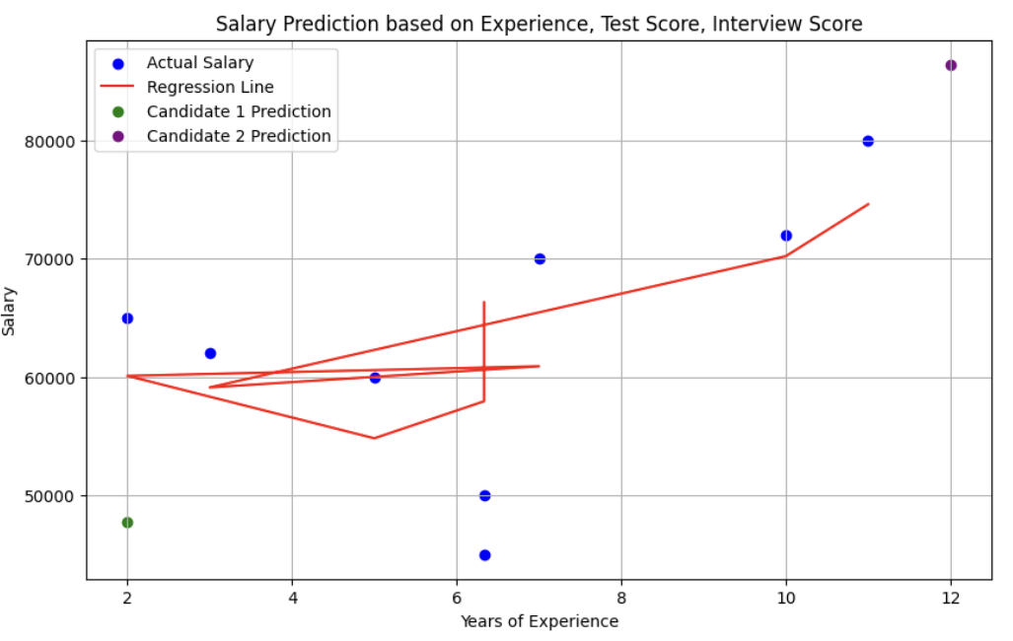

**LABORATORY PROGRAM – 5**

**Build Logistic Regression Model for a given dataset**

OBSERVATION BOOK

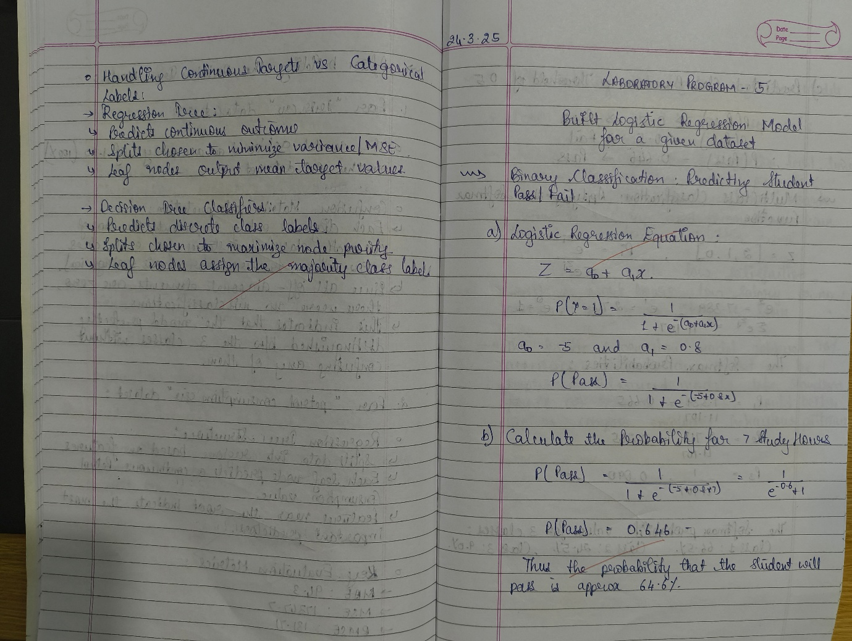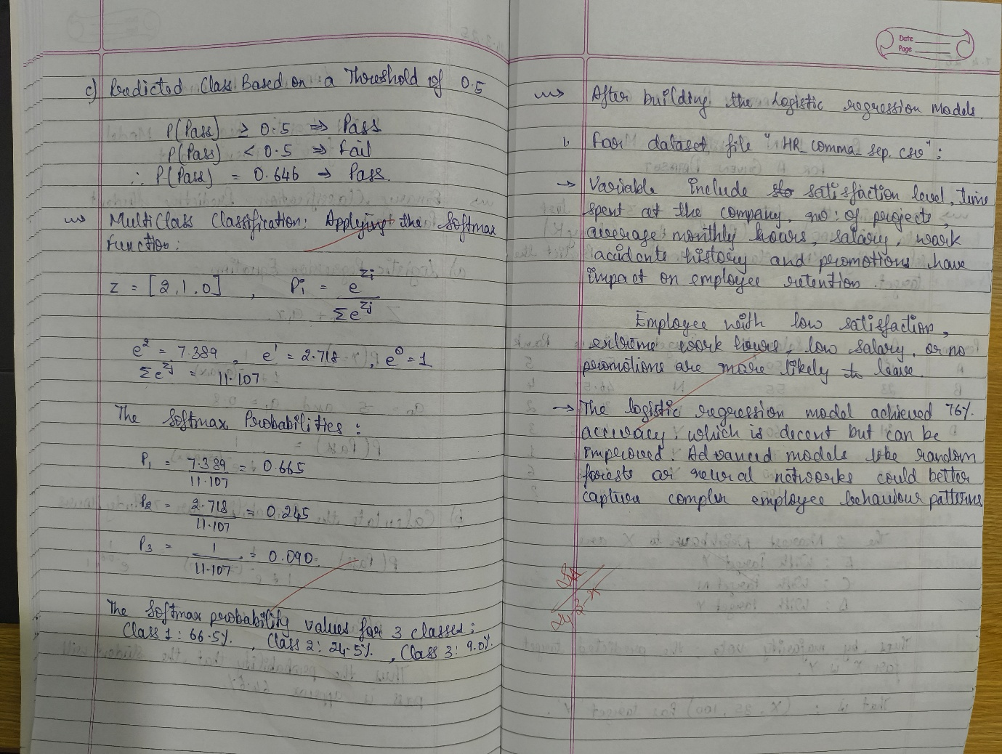

**CODE WITH OUTPUT**

import pandas as pd

from matplotlib import pyplot as plt

*# %matplotlib inline*

*#"%matplotlib inline" will make your plot outputs appear and be stored within the notebook.*

df = pd.read_csv("insurance_data.csv")

df.head()

plt.scatter(df.age,df.bought_insurance,marker='+',color='red')

from sklearn.model_selection import train_test_split

X_train, X_test, y_train, y_test = train_test_split(df[['age']],df.bought_insurance,train_size=0.9,random_state=10)

X_train.shape

X_test

from sklearn.linear_model import LogisticRegression

model = LogisticRegression()

model.fit(X_train, y_train)

X_test

y_test

y_predicted = model.predict(X_test)

y_predicted

model.score(X_test,y_test)

model.predict_proba(X_test)

y_predicted = model.predict([[60]])

y_predicted

*#model.coef_ indicates value of m in y=m*x + b equation*

model.coef_

*#model.intercept_ indicates value of b in y=m*x + b equation*

model.intercept_

*#Lets defined sigmoid function now and do the math with hand*

import math

def sigmoid(x):

return 1 / (1 + math.exp(-x))

def prediction_function(age):

z = 0.127 * age - 4.973 *# 0.12740563 ~ 0.0127 and -4.97335111 ~ -4.97*

y = sigmoid(z)

return y

age = 35

prediction_function(age)

"""0.37 is less than 0.5 which means person with 35 will not buy the insurance"""

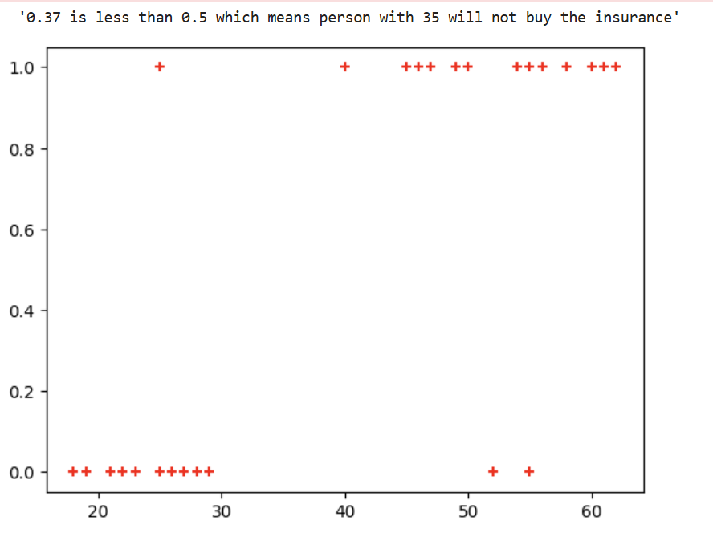

*# Import necessary libraries*

import pandas as pd

from sklearn.datasets import load_iris

from sklearn.model_selection import train_test_split

from sklearn.linear_model import LogisticRegression

from sklearn.metrics import accuracy_score

from sklearn import metrics

import matplotlib.pyplot as plt

*# Load the Iris dataset*

iris = pd.read_csv("iris.csv")

iris.head()

X=iris.drop('species',axis='columns')*# Features (sepal length, sepal width, petal length, petal width)*

y = iris.species *# Target labels (0: Setosa, 1: Versicolor, 2: Virginica)*

*# Split the dataset into 80% training and 20% testing*

X_train, X_test, y_train, y_test = train_test_split(X, y, test_size=0.2, random_state=42)

*# Initialize the Multinomial Logistic Regression model*

*# Use 'multinomial' for multi-class classification and 'lbfgs' solver*

model = LogisticRegression(multi_class='multinomial')

*# Train the model on the training data*

model.fit(X_train, y_train)

*# Make predictions on the test data*

y_pred = model.predict(X_test)

*# Calculate the accuracy of the model on the test data*

accuracy = accuracy_score(y_test, y_pred)

*# Display the accuracy*

print(f"Accuracy of the Multinomial Logistic Regression model on the test set: {accuracy:.2f}")

confusion_matrix = metrics.confusion_matrix(y_test, y_pred)

cm_display = metrics.ConfusionMatrixDisplay(confusion_matrix = confusion_matrix, display_labels = ["Setosa", "Versicolor", "Virginica"])

cm_display.plot()

plt.show()

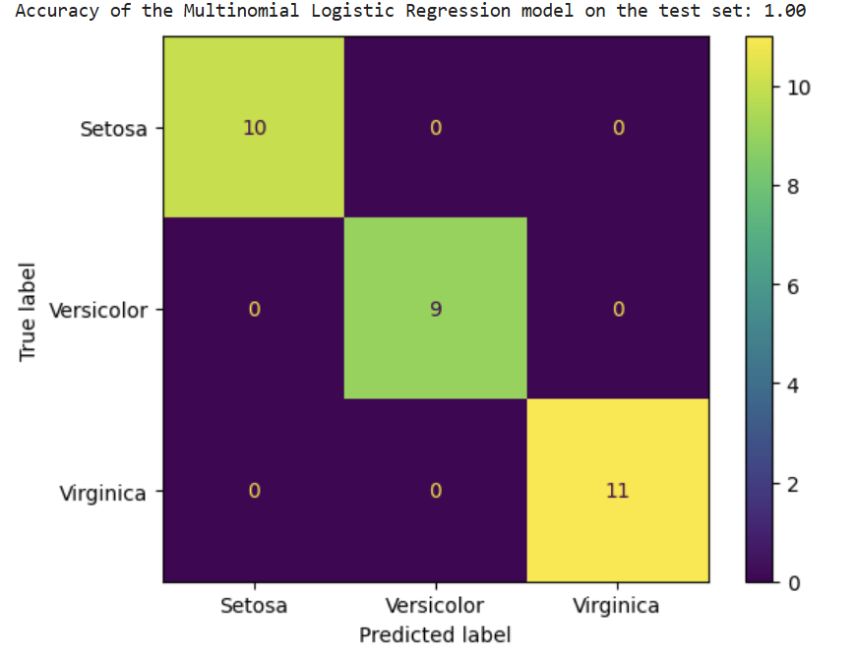

**LABORATORY PROGRAM – 6**

**Build KNN Classification model for a given dataset.**

OBSERVATION BOOK

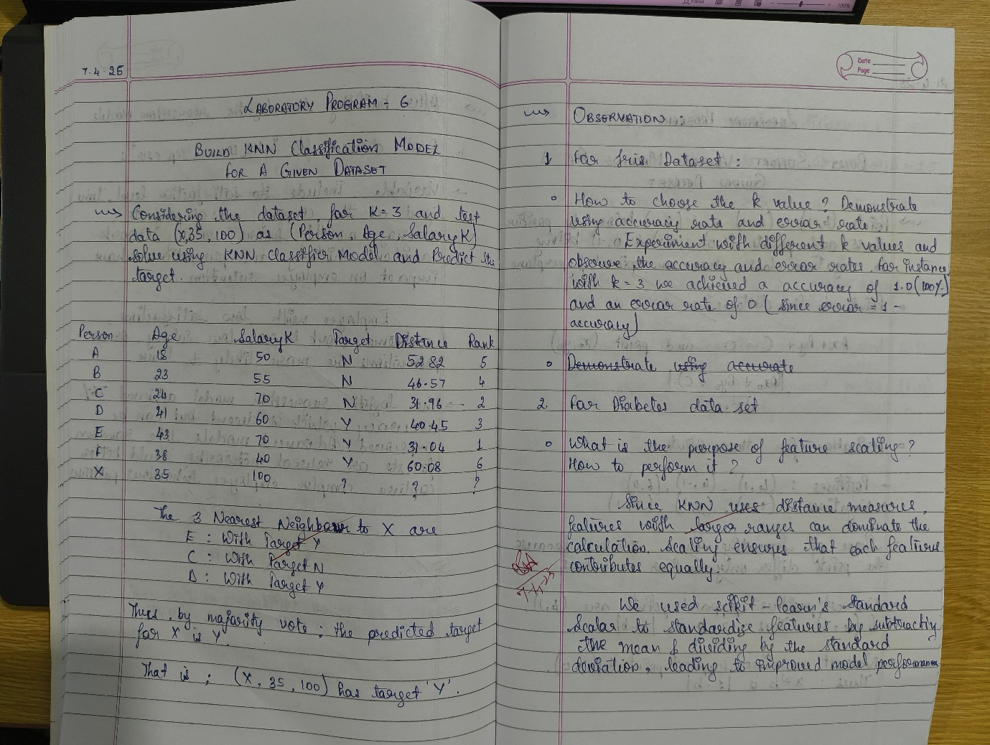

**CODE WITH OUTPUT**

*# Import necessary libraries*

import pandas as pd

import numpy as np

import matplotlib.pyplot as plt

import seaborn as sns

*# For model building and evaluation*

from sklearn.model_selection import train_test_split

from sklearn.preprocessing import StandardScaler

from sklearn.neighbors import KNeighborsClassifier

from sklearn.metrics import accuracy_score, confusion_matrix, classification_report

*# -------------------------- Part 1: IRIS Dataset -------------------------- #*

*# Load the iris dataset (ensure iris.csv is in the same directory or provide correct path)*

iris_df = pd.read_csv("iris.csv")

*# Separate features and target*

X_iris = iris_df.drop("species", axis=1)

y_iris = iris_df["species"]

*# Split the data (80% training, 20% testing)*

X_train_iris, X_test_iris, y_train_iris, y_test_iris = train_test_split(

X_iris, y_iris, test_size=0.2, random_state=42

)

*# Choose a value for k; here K=3 is used as an example.*

knn_iris = KNeighborsClassifier(n_neighbors=3)

*# Train the model on training data*

knn_iris.fit(X_train_iris, y_train_iris)

*# Predict on test data*

y_pred_iris = knn_iris.predict(X_test_iris)

*# Calculate accuracy score*

acc_iris = accuracy_score(y_test_iris, y_pred_iris)

print("IRIS Dataset Accuracy Score:", acc_iris)

*# Compute confusion matrix and classification report*

cm_iris = confusion_matrix(y_test_iris, y_pred_iris)

print("\nIRIS Dataset Confusion Matrix:\n", cm_iris)

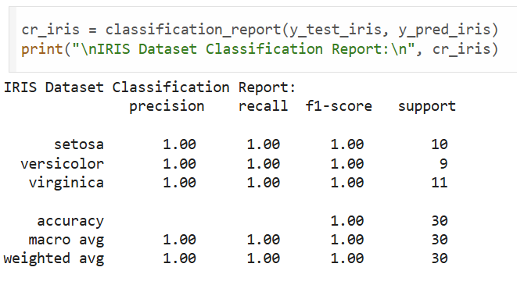

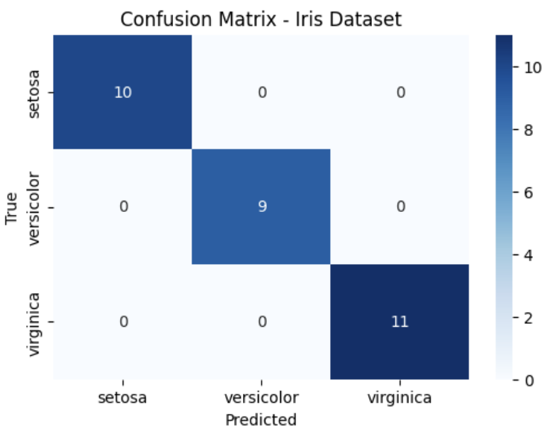

*# ----------------------- Part 2: Diabetes Dataset ------------------------- #*

*# Load the diabetes dataset (ensure diabetes.csv is in the same directory or provide correct path)*

diabetes_df = pd.read_csv("diabetes.csv")

*# Separate features and target (Outcome column is assumed to be the target)*

X_diabetes = diabetes_df.drop("Outcome", axis=1)

y_diabetes = diabetes_df["Outcome"]

*# Perform feature scaling on the features*

scaler = StandardScaler()

X_scaled_diabetes = scaler.fit_transform(X_diabetes)

*# Split the scaled data (80% training, 20% testing)*

X_train_diab, X_test_diab, y_train_diab, y_test_diab = train_test_split(

X_scaled_diabetes, y_diabetes, test_size=0.2, random_state=42

)

*# Choose a value for k; here K=5 is used as an example.*

knn_diabetes = KNeighborsClassifier(n_neighbors=5)

*# Train the model on training data*

knn_diabetes.fit(X_train_diab, y_train_diab)

*# Predict on test data*

y_pred_diab = knn_diabetes.predict(X_test_diab)

*# Calculate accuracy score*

acc_diab = accuracy_score(y_test_diab, y_pred_diab)

print("Diabetes Dataset Accuracy Score:", acc_diab)

*# Compute confusion matrix and classification report*

cm_diab = confusion_matrix(y_test_diab, y_pred_diab)

print("\nDiabetes Dataset Confusion Matrix:\n", cm_diab)

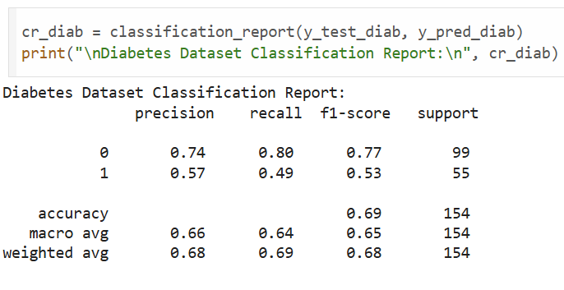

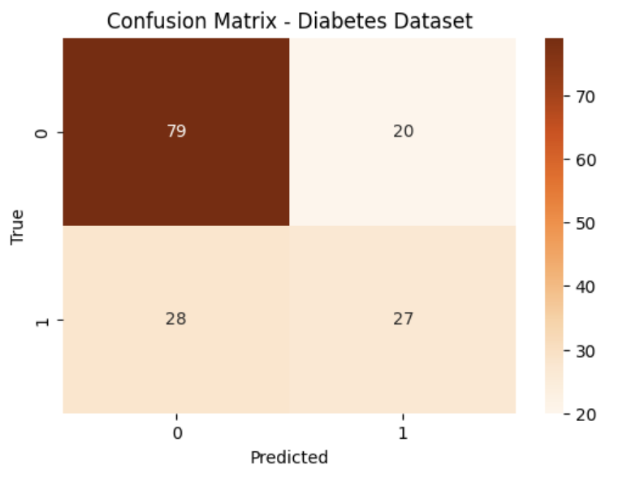

*# -------------------------- Load the Dataset -------------------------- #*

*# Load heart.csv (make sure the file is in your working directory)*

heart_df = pd.read_csv("heart.csv")

*# Display the first few rows to check the data*

heart_df.head()

*# -------------------------- Data Preparation -------------------------- #*

*# Separate features and target*

X_heart = heart_df.drop("target", axis=1)

y_heart = heart_df["target"]

*# Perform feature scaling (important for distance-based algorithms like KNN)*

scaler = StandardScaler()

X_scaled = scaler.fit_transform(X_heart)

*# Split data into training and testing sets (80% train, 20% test)*

X_train, X_test, y_train, y_test = train_test_split(X_scaled, y_heart, test_size=0.2, random_state=42)

*# -------------------------- Finding the Best k -------------------------- #*

*# We will try a range of k values (neighbors) and select the one with maximum accuracy.*

k_range = range(1, 21)

accuracy_scores = []

for k in k_range:

knn = KNeighborsClassifier(n_neighbors=k)

knn.fit(X_train, y_train)

y_pred = knn.predict(X_test)

acc = accuracy_score(y_test, y_pred)

accuracy_scores.append(acc)

print(f"k = {k} --> Accuracy: {acc:.4f}")

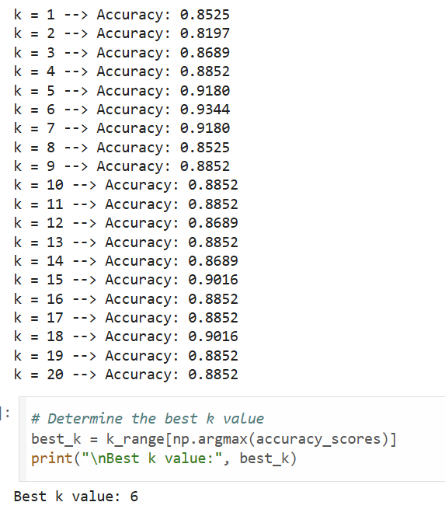

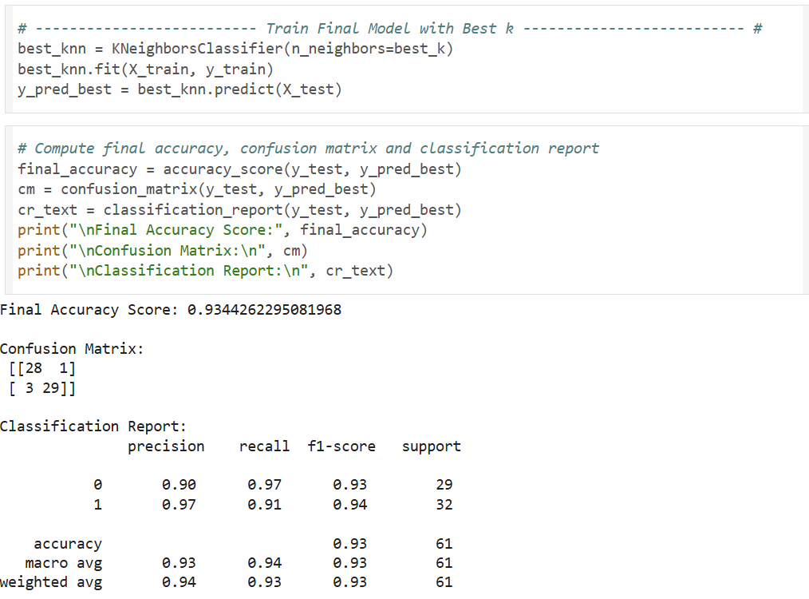**LABORATORY PROGRAM – 7**

**Build Support vector machine model for a given dataset**

OBSERVATION BOOK

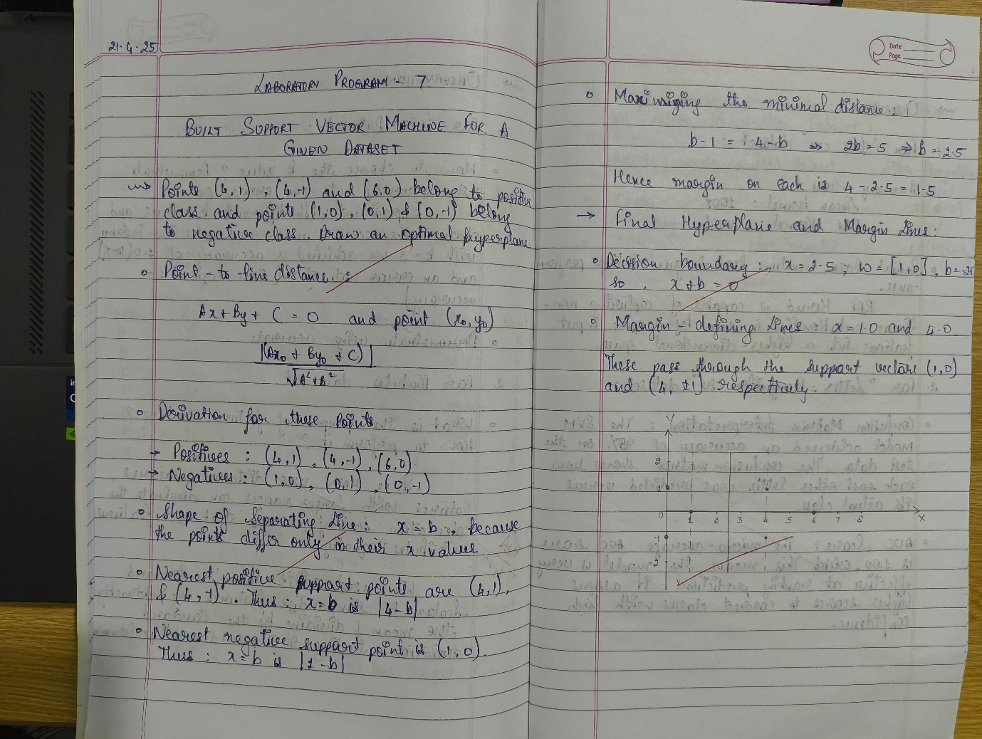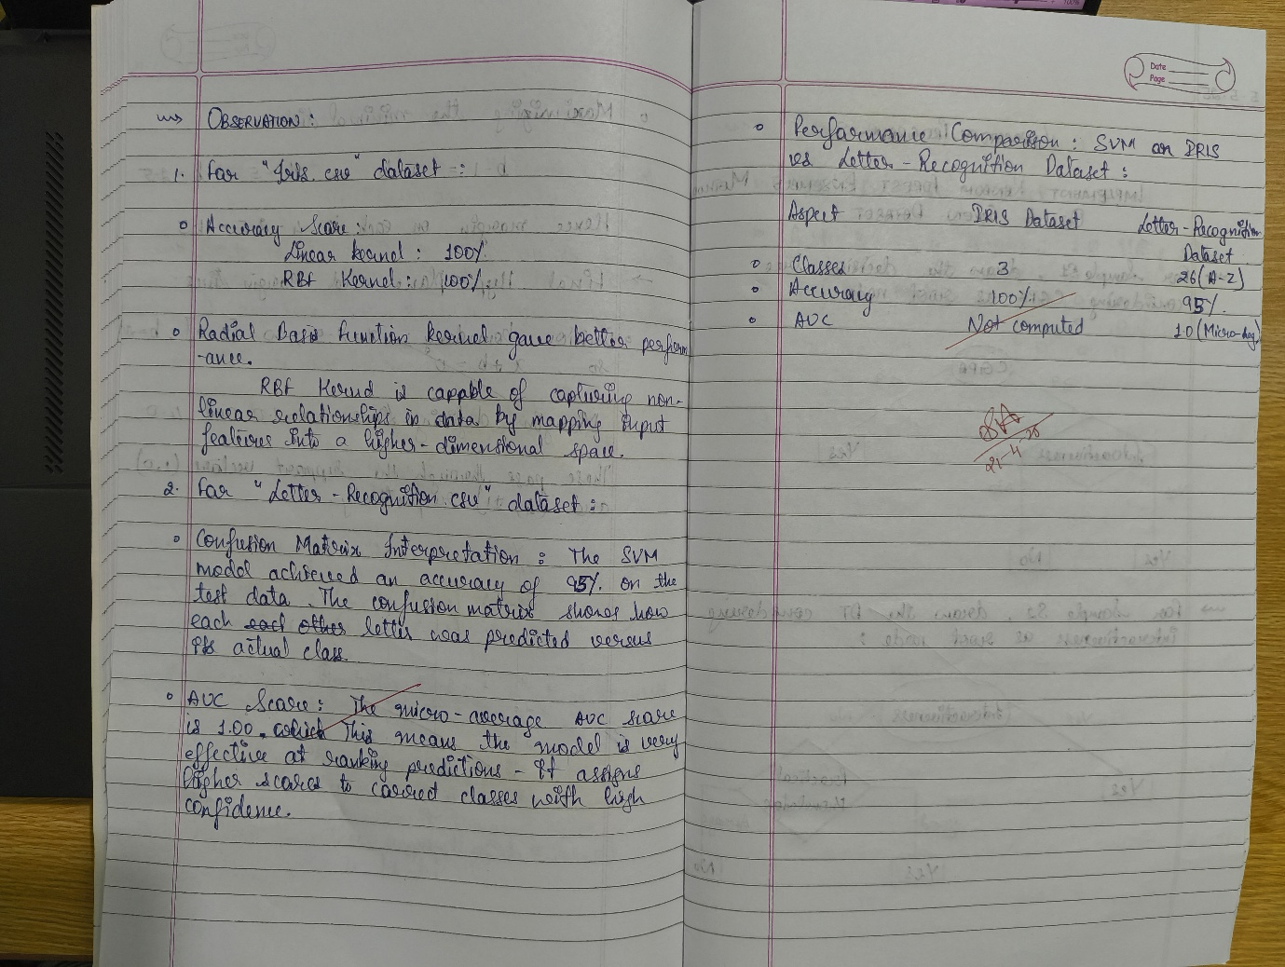

**CODE WITH OUTPUT**

import numpy as np

import matplotlib.pyplot as plt

from sklearn.svm import SVC

*# Data points*

X = np.array([[4, 1], [4, -1], [6, 0], [1, 0], [0, 1], [0, -1]])

y = np.array([1, 1, 1, -1, -1, -1])

*# Fit linear SVM with a very large C to approximate hard-margin*

clf = SVC(kernel='linear', C=1e6)

clf.fit(X, y)

*# Extract model parameters*

w = clf.coef_[0]

b = clf.intercept_[0]

*# Compute decision boundary and margins*

xx = np.linspace(-1, 7, 500)

yy = -(w[0] * xx + b) / w[1]

*# Margin offset: distance = 1/||w||*

margin = 1 / np.linalg.norm(w)

yy_down = yy - np.sqrt(1 + (w[0] / w[1])**2) * margin

yy_up = yy + np.sqrt(1 + (w[0] / w[1])**2) * margin

*# Plotting*

plt.figure(figsize=(8, 6))

plt.scatter(X[y == 1, 0], X[y == 1, 1], c='blue', marker='o', label='Positive class')

plt.scatter(X[y == -1, 0], X[y == -1, 1], c='red', marker='s', label='Negative class')

plt.plot(xx, yy, 'k-', label='Decision boundary')

plt.plot(xx, yy_down, 'k--', label='Margin lines')

plt.plot(xx, yy_up, 'k--')

plt.xlabel('x')

plt.ylabel('y')

plt.legend()

plt.title('Optimal Hyperplane and Margins')

plt.grid(True)

plt.show()

*# Print hyperplane equation*

print(f"Hyperplane: {w[0]:.3f}x + {w[1]:.3f}y + ({b:.3f}) = 0")

print(f"Margin on each side: {margin:.3f}")

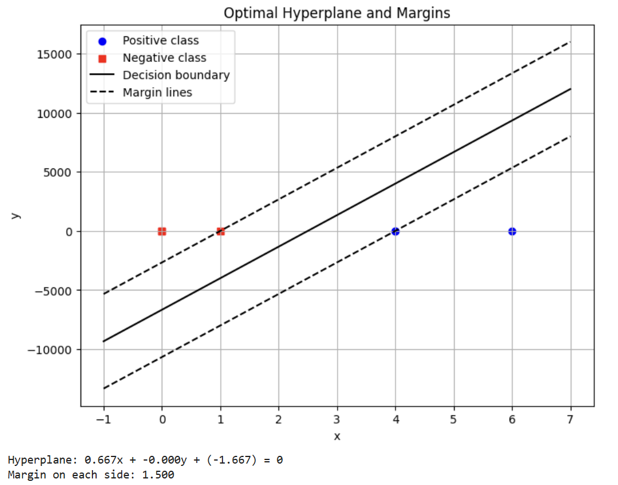

import pandas as pd

*# Load both datasets*

iris_df = pd.read_csv("/content/iris.csv")

*# 1. IRIS DATASET - SVM with RBF and Linear Kernels*

X_iris = iris_df.drop("species", axis=1)

y_iris = iris_df["species"]

*# Encode labels*

le_iris = LabelEncoder()

y_iris_encoded = le_iris.fit_transform(y_iris)

*# Split dataset*

X_train_iris, X_test_iris, y_train_iris, y_test_iris = train_test_split(X_iris, y_iris_encoded, test_size=0.2, random_state=42)

*# Train models*

svm_rbf = SVC(kernel='rbf')

svm_linear = SVC(kernel='linear')

svm_rbf.fit(X_train_iris, y_train_iris)

svm_linear.fit(X_train_iris, y_train_iris)

*# Predictions*

y_pred_rbf = svm_rbf.predict(X_test_iris)

y_pred_linear = svm_linear.predict(X_test_iris)

*# Accuracy and Confusion Matrix*

acc_rbf = accuracy_score(y_test_iris, y_pred_rbf)

acc_linear = accuracy_score(y_test_iris, y_pred_linear)

cm_rbf = confusion_matrix(y_test_iris, y_pred_rbf)

cm_linear = confusion_matrix(y_test_iris, y_pred_linear)

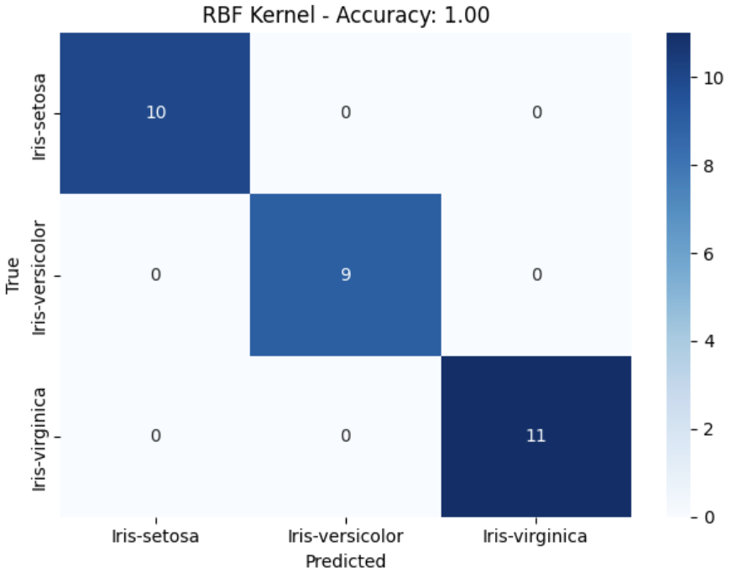 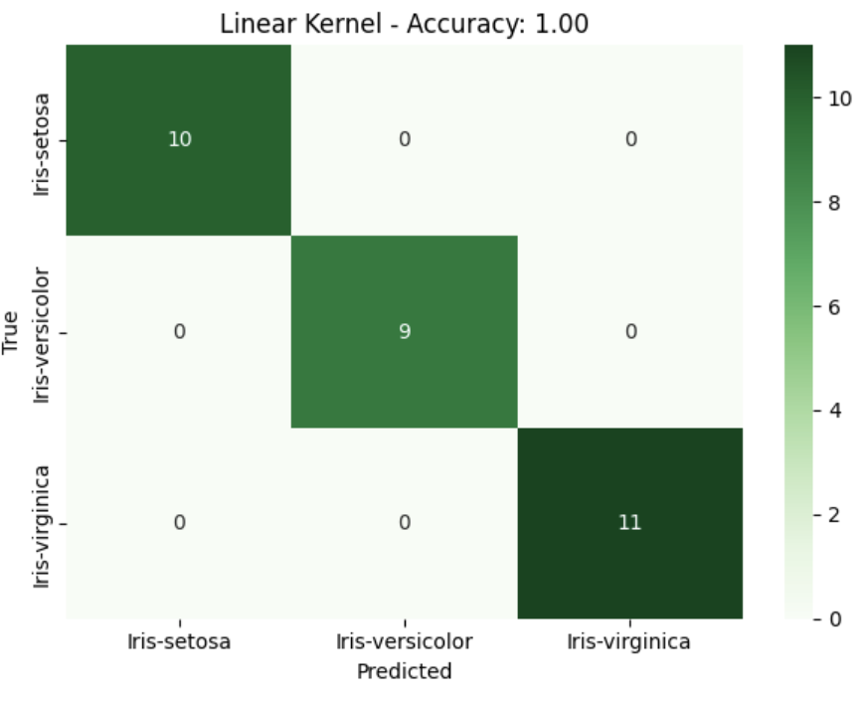

*# Load dataset*

letter_df = pd.read_csv("/content/letter-recognition.csv") *# Update path if needed*

letter_df['letter'] = LabelEncoder().fit_transform(letter_df['letter'])

*# Split features and labels*

X = letter_df.drop('letter', axis=1)

y = letter_df['letter']

*# Train-test split*

X_train, X_test, y_train, y_test = train_test_split(X, y, test_size=0.2, random_state=42)

*# Standardize*

scaler = StandardScaler()

X_train = scaler.fit_transform(X_train)

X_test = scaler.transform(X_test)

*# Train SVM*

svm = SVC(kernel='rbf', probability=True)

svm.fit(X_train, y_train)

y_pred = svm.predict(X_test)

y_prob = svm.predict_proba(X_test)

*# Accuracy and Confusion Matrix*

print("Accuracy:", accuracy_score(y_test, y_pred))

print("Confusion Matrix:\n", confusion_matrix(y_test, y_pred))

*# ROC and AUC (one-vs-rest)*

y_test_bin = label_binarize(y_test, classes=np.unique(y))

n_classes = y_test_bin.shape[1]

fpr = dict()

tpr = dict()

roc_auc = dict()

for i in range(n_classes):

fpr[i], tpr[i], _ = roc_curve(y_test_bin[:, i], y_prob[:, i])

roc_auc[i] = auc(fpr[i], tpr[i])

*# Plot ROC Curve*

plt.figure(figsize=(10, 7))

colors = cycle(['aqua', 'darkorange', 'cornflowerblue', 'green', 'red', 'purple'])

for i, color in zip(range(n_classes), colors):

plt.plot(fpr[i], tpr[i], color=color, lw=2,

label=f'Class {i} (AUC = {roc_auc[i]:0.2f})')

plt.plot([0, 1], [0, 1], 'k--', lw=2)

plt.xlabel("False Positive Rate")

plt.ylabel("True Positive Rate")

plt.title("Multi-class ROC Curve")

plt.legend(loc="lower right")

plt.grid()

plt.show()

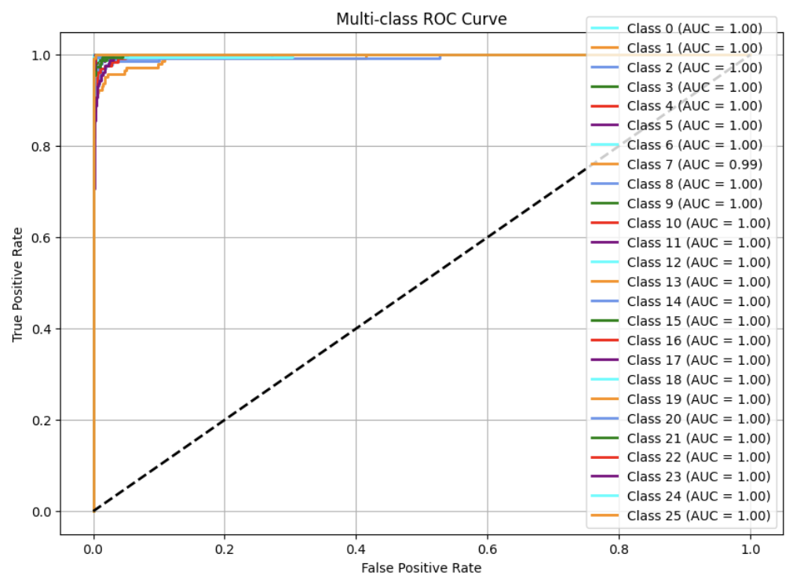

**LABORATORY PROGRAM – 8**

**Implement Random forest ensemble method on a given dataset.**

OBSERVATION BOOK

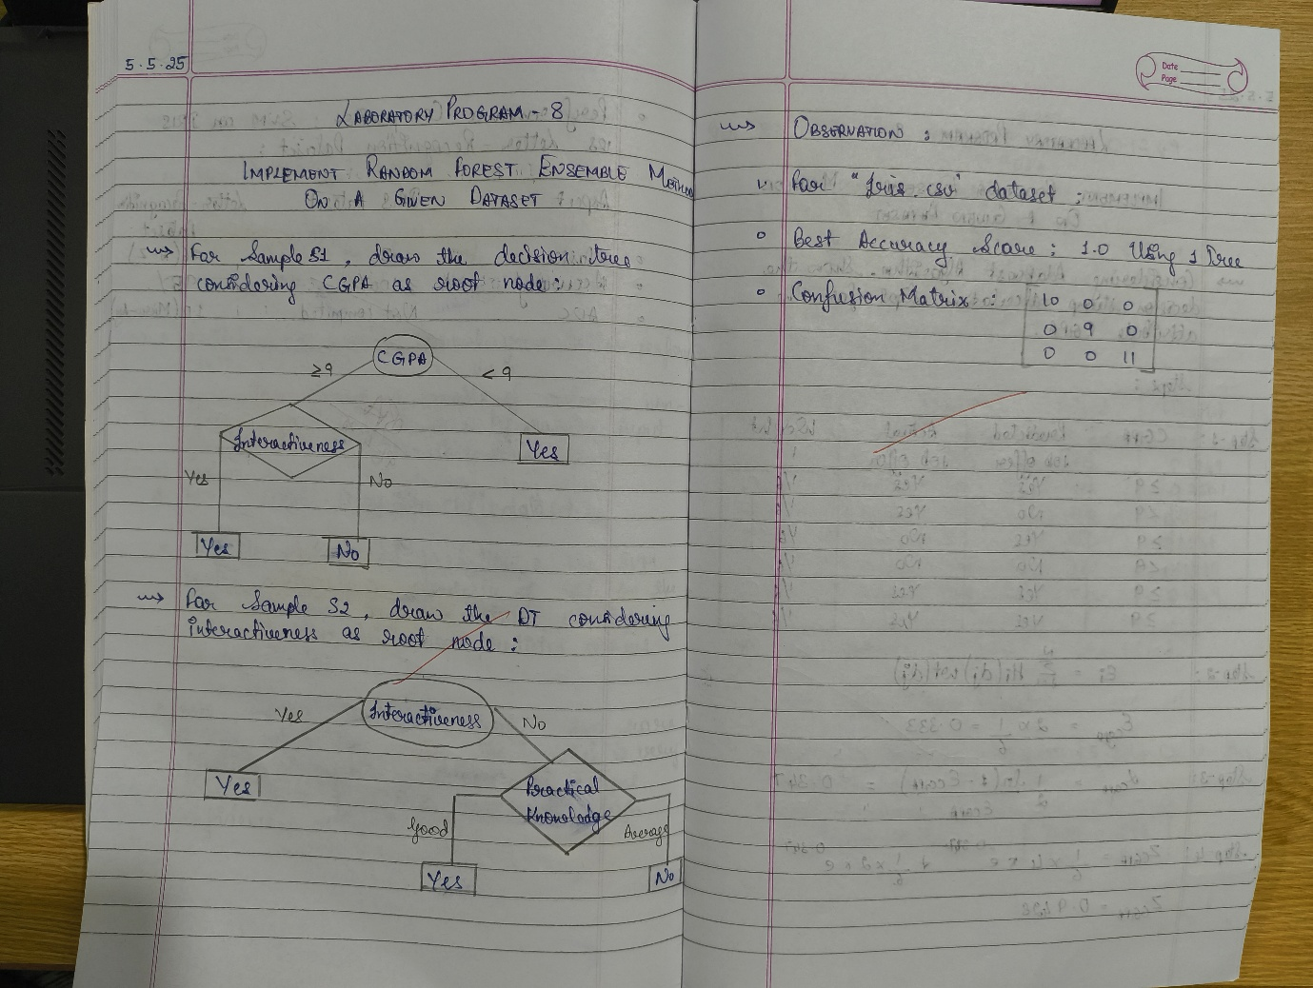

**CODE WITH OUTPUT**

import pandas as pd

from sklearn.model_selection import train_test_split

from sklearn.ensemble import RandomForestClassifier

from sklearn.metrics import accuracy_score, confusion_matrix

import matplotlib.pyplot as plt

*# Load the dataset*

df = pd.read_csv("iris.csv") *# Adjust filename if needed*

*# Prepare data*

X = df.drop(columns=["species"]) *# Assuming 'species' is the target column*

y = df["species"]

*# Split dataset*

X_train, X_test, y_train, y_test = train_test_split(X, y, test_size=0.2, random_state=42)

*# Default Random Forest with 10 trees*

rf_default = RandomForestClassifier(n_estimators=10, random_state=42)

rf_default.fit(X_train, y_train)

y_pred_default = rf_default.predict(X_test)

acc_default = accuracy_score(y_test, y_pred_default)

conf_matrix_default = confusion_matrix(y_test, y_pred_default)

print(f"Default RF (10 trees) Accuracy: {acc_default}")

print("Confusion Matrix:\n", conf_matrix_default)

*# Try different numbers of trees to find the best*

best_acc = 0

best_n = 10

acc_list = []

for n in range(1, 101):

rf = RandomForestClassifier(n_estimators=n, random_state=42)

rf.fit(X_train, y_train)

y_pred = rf.predict(X_test)

acc = accuracy_score(y_test, y_pred)

acc_list.append((n, acc))

if acc > best_acc:

best_acc = acc

best_n = n

best_conf_matrix = confusion_matrix(y_test, y_pred)

print(f"\nBest Accuracy: {best_acc} using {best_n} trees")

print("Best Confusion Matrix:\n", best_conf_matrix)

*# Plot accuracy vs number of trees*

x_vals, y_vals = zip(*acc_list)

plt.plot(x_vals, y_vals, marker='o')

plt.title("Accuracy vs Number of Trees")

plt.xlabel("Number of Trees")

plt.ylabel("Accuracy")

plt.grid(True)

plt.show()

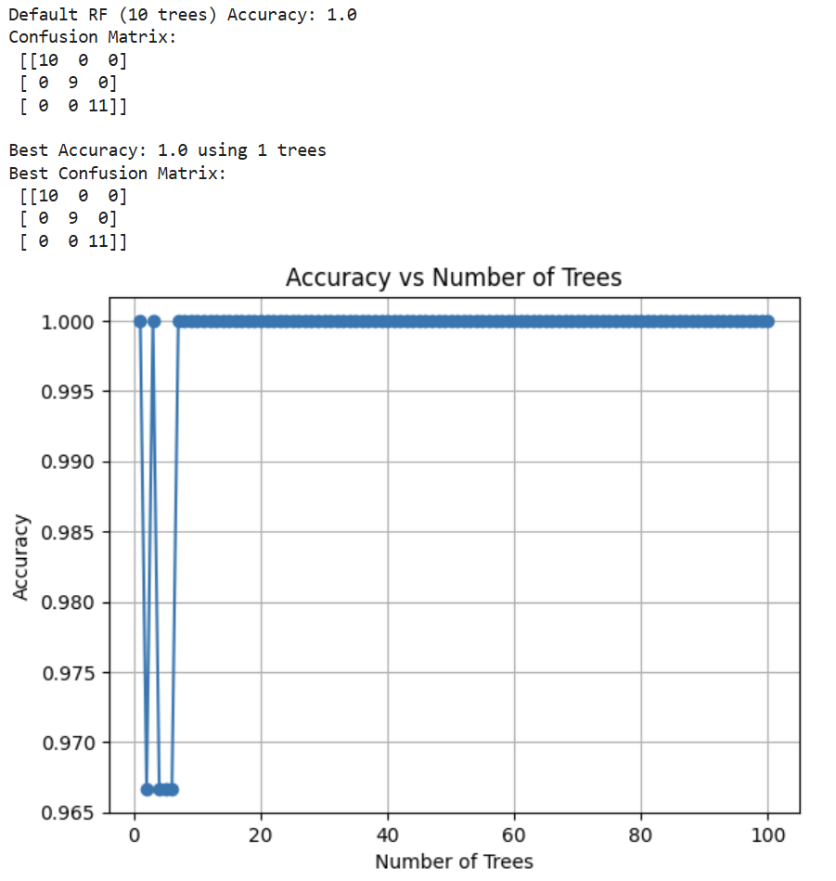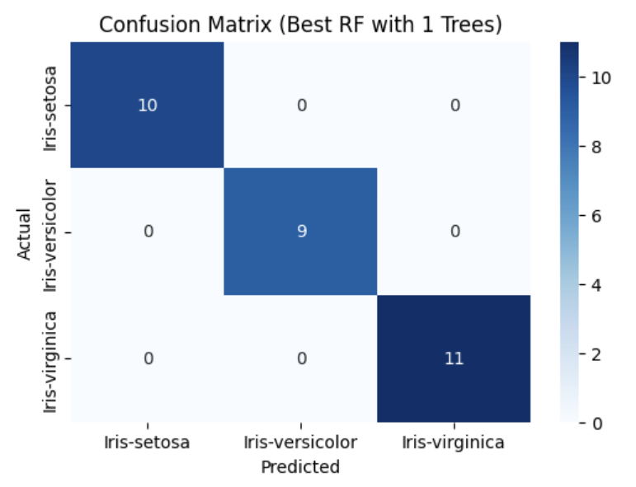

**LABORATORY PROGRAM – 9**

**Implement Boosting ensemble method on a given dataset.**

OBSERVATION BOOK

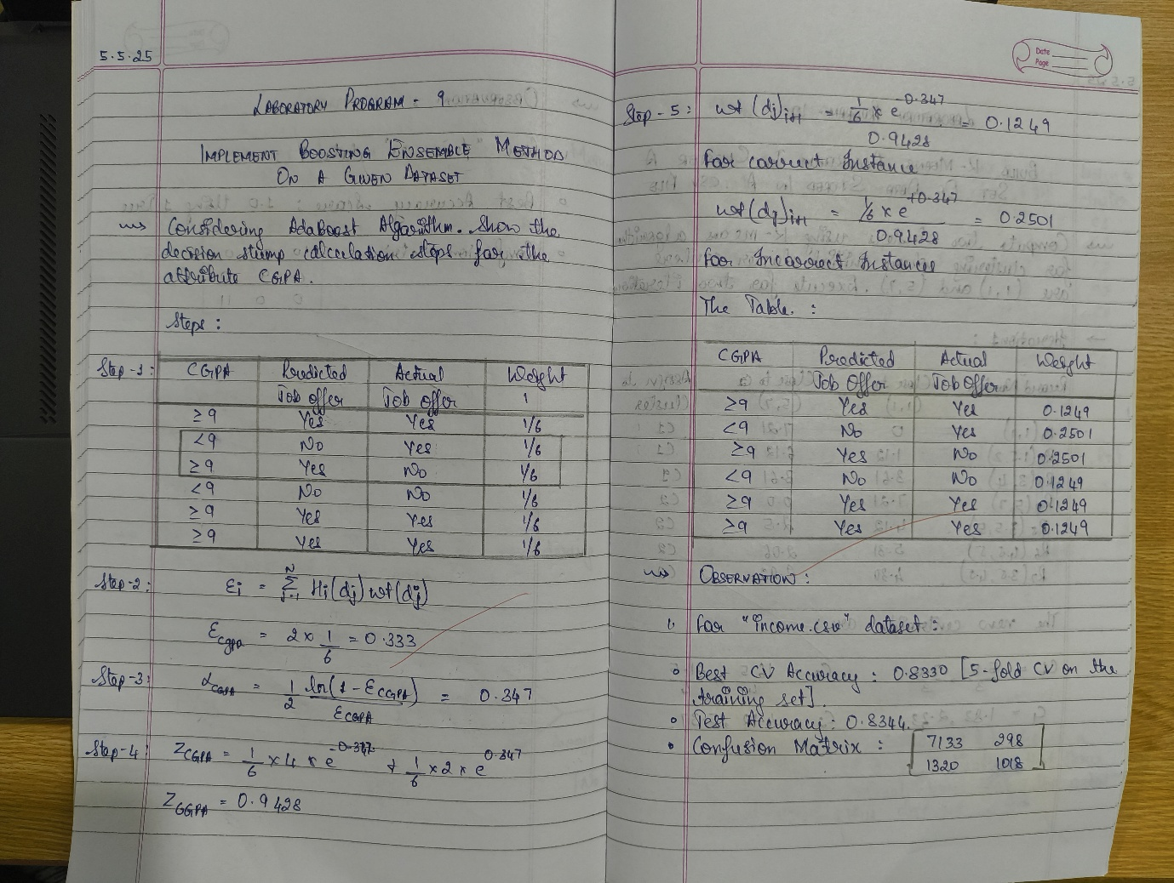

**CODE WITH OUTPUT**

import pandas as pd

import matplotlib.pyplot as plt

from sklearn.model_selection import train_test_split, cross_val_score

from sklearn.preprocessing import OneHotEncoder, StandardScaler

from sklearn.compose import ColumnTransformer

from sklearn.pipeline import Pipeline

from sklearn.ensemble import AdaBoostClassifier

from sklearn.metrics import accuracy_score, confusion_matrix, ConfusionMatrixDisplay

*# Load dataset*

data = pd.read_csv('income.csv')

*# Display basic info*

print("First five rows:")

print(data.head())

print(f"\nDataset shape: {data.shape}")

*# Define features and target*

target_column = 'income_level'

y = data[target_column]

X = data.drop(columns=[target_column])

*# Identify categorical vs numerical columns*

categorical_cols = X.select_dtypes(include=['object', 'category']).columns.tolist()

numerical_cols = X.select_dtypes(include=['int64', 'float64']).columns.tolist()

print(f"\nNumerical columns: {numerical_cols}")

print(f"Categorical columns: {categorical_cols}")

*# Preprocessor: scale numericals, one-hot encode categoricals*

preprocessor = ColumnTransformer(

transformers=[

('num', StandardScaler(), numerical_cols),

('cat', OneHotEncoder(handle_unknown='ignore'), categorical_cols)

]

)

*# Initial AdaBoost model with 10 estimators*

pipeline = Pipeline([

('preprocess', preprocessor),

('clf', AdaBoostClassifier(n_estimators=10, random_state=42))

])

*# Split into train/test sets*

X_train, X_test, y_train, y_test = train_test_split(

X, y, test_size=0.2, random_state=42, stratify=y

)

*# Train and evaluate initial model*

pipeline.fit(X_train, y_train)

y_pred = pipeline.predict(X_test)

initial_acc = accuracy_score(y_test, y_pred)

print(f"Initial test accuracy (n_estimators=10): {initial_acc:.4f}")

*# Hyperparameter tuning: find best n_estimators*

tree_counts = list(range(10, 201, 10)) *# 10,20,...,200*

cv_scores = []

for n in tree_counts:

model = Pipeline([

('preprocess', preprocessor),

('clf', AdaBoostClassifier(n_estimators=n, random_state=42))

])

scores = cross_val_score(

model, X_train, y_train, cv=5, scoring='accuracy', n_jobs=-1

)

mean_score = scores.mean()

cv_scores.append(mean_score)

print(f"n_estimators={n}: CV mean accuracy={mean_score:.4f}")

*# Plot CV accuracy vs. number of estimators*

plt.figure()

plt.plot(tree_counts, cv_scores, marker='o')

plt.title('AdaBoost CV Accuracy vs. n_estimators')

plt.xlabel('Number of Estimators')

plt.ylabel('CV Mean Accuracy')

plt.grid(True)

plt.tight_layout()

plt.show()

*# Determine optimal number of trees*

best_score = max(cv_scores)

best_n = tree_counts[cv_scores.index(best_score)]

print(f"\nBest CV accuracy={best_score:.4f} with n_estimators={best_n}")

*# Retrain and evaluate best model*

best_model = Pipeline([

('preprocess', preprocessor),

('clf', AdaBoostClassifier(n_estimators=best_n, random_state=42))

])

best_model.fit(X_train, y_train)

y_best = best_model.predict(X_test)

best_test_acc = accuracy_score(y_test, y_best)

print(f"Test accuracy with best n_estimators ({best_n}): {best_test_acc:.4f}")

*# Plot comparison of initial vs. best test accuracy*

plt.figure()

plt.bar(['n=10', f'n={best_n}'], [initial_acc, best_test_acc])

plt.title('Test Accuracy: Initial vs. Optimized')

plt.ylabel('Accuracy')

plt.ylim(0, 1)

plt.tight_layout()

plt.show()

*# Plot confusion matrix for best model*

cm = confusion_matrix(y_test, y_best)

labels = best_model.named_steps['clf'].classes_

disp = ConfusionMatrixDisplay(confusion_matrix=cm, display_labels=labels)

plt.figure()

disp.plot(cmap=plt.cm.Blues)

plt.title('Confusion Matrix for Best AdaBoost Model')

plt.tight_layout()

plt.show()

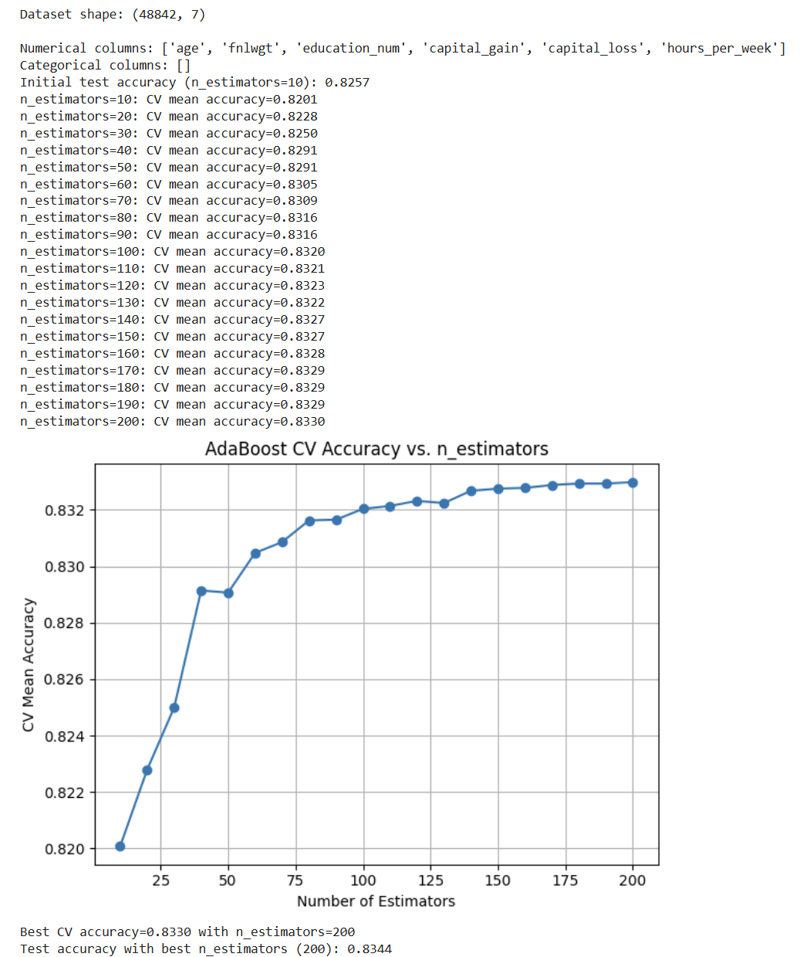

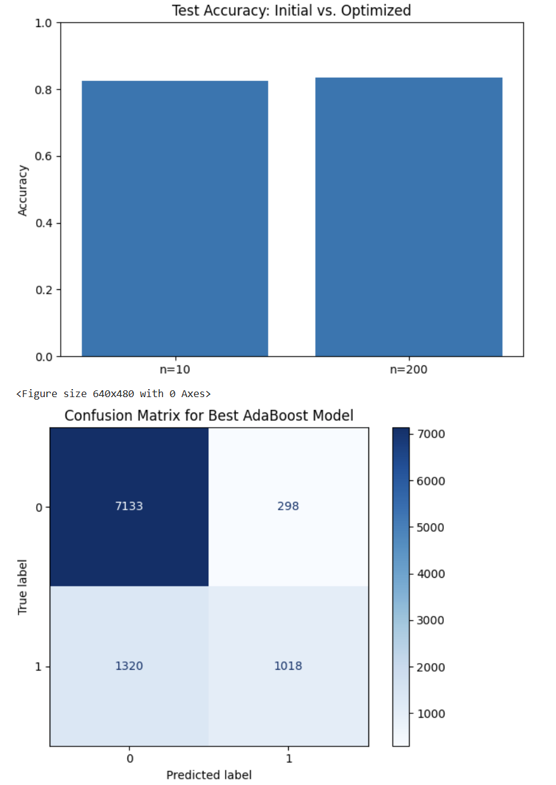

**LABORATORY PROGRAM – 10**

**Build k-Means algorithm to cluster a set of data stored in a .CSV file.**

OBSERVATION BOOK

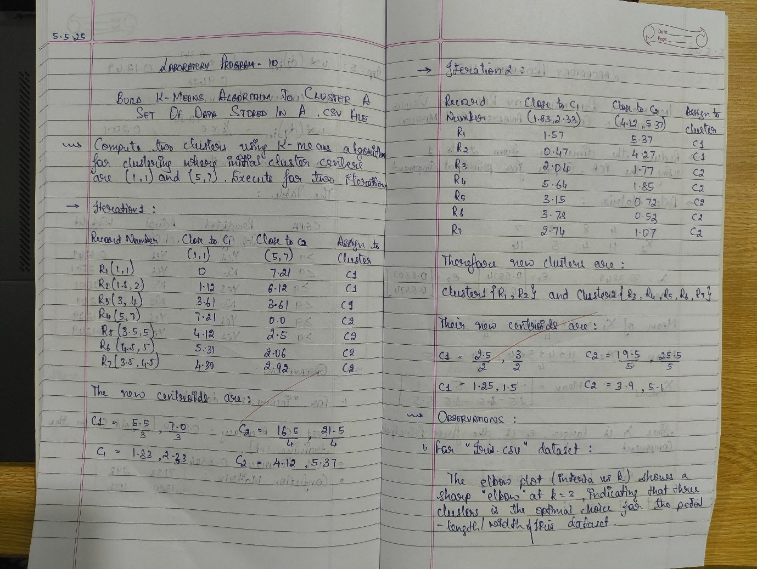

**CODE WITH OUTPUT**

import pandas as pd

import numpy as np

import matplotlib.pyplot as plt

from sklearn.datasets import load_iris

from sklearn.preprocessing import StandardScaler

from sklearn.cluster import KMeans

from sklearn.metrics import confusion_matrix, ConfusionMatrixDisplay

def load_data(csv_path='iris.csv'):

"""

Try loading from csv_path; if not found, load via sklearn.

Expects columns: sepal_length, sepal_width, petal_length, petal_width, species.

Returns DataFrame with a 'species' column.

"""

try:

df = pd.read_csv(csv_path)

*# Fixed typo here: use c.strip().replace, not ace()*

df.columns = [c.strip().replace(' ', '_') for c in df.columns]

except FileNotFoundError:

iris = load_iris()

df = pd.DataFrame(

data=np.c_[iris['data'], iris['target']],

columns=iris['feature_names'] + ['target']

)

df.columns = [c.strip().replace(' (cm)', '').replace(' ', '_')

for c in df.columns]

df['species'] = df['target'].map(lambda x: iris['target_names'][int(x)])

return df

def preprocess(df):

"""

Select only petal_length & petal_width, then standard-scale.

Returns scaled numpy array.

"""

X = df[['petal_length', 'petal_width']].values

scaler = StandardScaler()

X_scaled = scaler.fit_transform(X)

return X_scaled, scaler

def plot_elbow(X_scaled, max_k=10):

"""

Compute KMeans inertia for k=1..max_k and plot the elbow curve.

Returns list of inertias.

"""

inertias = []

ks = range(1, max_k + 1)

for k in ks:

km = KMeans(n_clusters=k, random_state=42)

km.fit(X_scaled)

inertias.append(km.inertia_)

plt.figure(figsize=(6, 4))

plt.plot(ks, inertias, 'o-', linewidth=2)

plt.xlabel('Number of clusters (k)')

plt.ylabel('Inertia')

plt.title('Elbow Method for Optimal k')

plt.xticks(ks)

plt.grid(True, linestyle='--', alpha=0.5)

plt.tight_layout()

plt.show()

return inertias

def run_kmeans(X_scaled, k):

"""

Fit KMeans with k clusters, return labels and fitted model.

"""

km = KMeans(n_clusters=k, random_state=42)

labels = km.fit_predict(X_scaled)

return km, labels

def plot_confusion(df, labels, k):

"""

Builds and displays a confusion matrix comparing true species vs. cluster.

"""

species_names = df['species'].unique()

species_to_num = {name: idx for idx, name in enumerate(species_names)}

true_nums = df['species'].map(species_to_num)

cm = confusion_matrix(true_nums, labels)

disp = ConfusionMatrixDisplay(

confusion_matrix=cm,

display_labels=[f"Cluster {i}" for i in range(k)]

)

fig, ax = plt.subplots(figsize=(6, 6))

disp.plot(ax=ax, cmap='Blues', colorbar=True)

ax.set_xlabel('Predicted Cluster')

ax.set_ylabel('True Species')

plt.title('K-Means Clustering Confusion Matrix')

plt.tight_layout()

plt.show()

cm_df = pd.DataFrame(

cm,

index=[f"True: {name}" for name in species_names],

columns=[f"Cluster {i}" for i in range(k)]

)

print("\nConfusion Matrix (counts):")

print(cm_df)

def main():

*# 1) Load data*

df = load_data('iris.csv')

if 'species' not in df.columns:

print("Error: 'species' column not found.")

return

*# 2) Preprocess*

X_scaled, scaler = preprocess(df)

*# 3) Elbow plot to decide k*

print("Generating elbow plot to find optimal k...")

inertias = plot_elbow(X_scaled, max_k=10)

*# 4) From the elbow you’ll typically see a bend at k=3*

optimal_k = 3

print(f"Choosing k = {optimal_k} (you can adjust this based on the plot).")

*# 5) Run K-Means and assign clusters*

km_model, labels = run_kmeans(X_scaled, optimal_k)

df['cluster'] = labels

*# 6) Visualize clusters in feature space*

plt.figure(figsize=(6, 4))

plt.scatter(

X_scaled[:, 0], X_scaled[:, 1],

c=labels, cmap='viridis', edgecolor='k', s=50

)

centroids = km_model.cluster_centers_

plt.scatter(

centroids[:, 0], centroids[:, 1],

marker='X', c='red', s=200, label='Centroids'

)

plt.xlabel('Scaled Petal Length')

plt.ylabel('Scaled Petal Width')

plt.title(f'K-Means Clusters (k={optimal_k})')

plt.legend()

plt.grid(True, linestyle='--', alpha=0.5)

plt.tight_layout()

plt.show()

*# 7) Confusion matrix vs. true species*

plot_confusion(df, labels, optimal_k)

if __name__ == "__main__":

main()

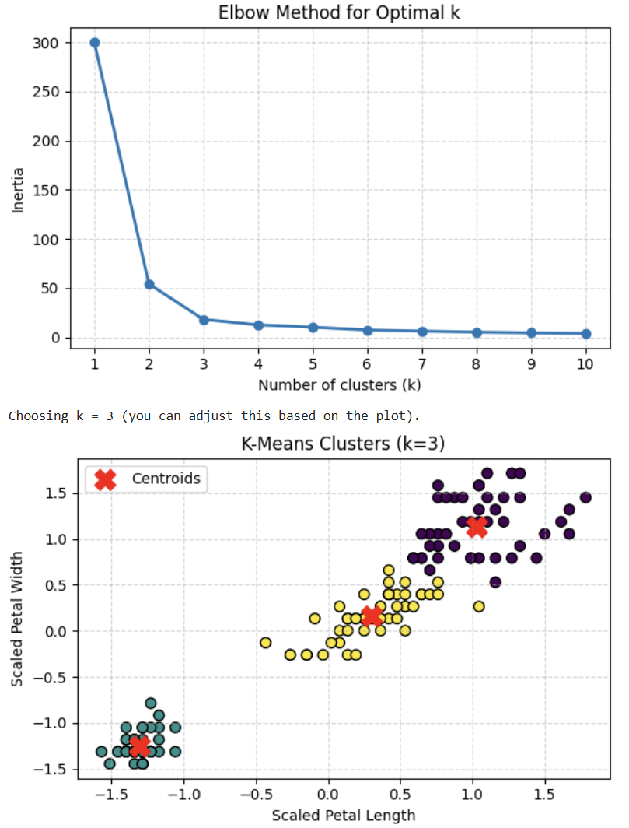 

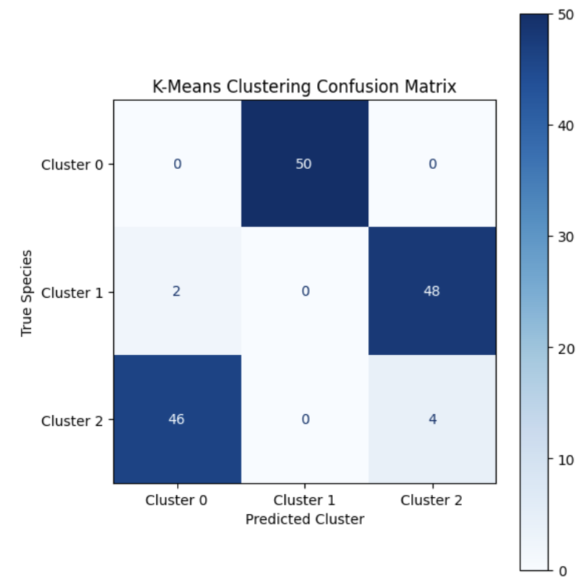

**LABORATORY PROGRAM – 11**

**Implement Dimensionality reduction using Principle Component Analysis (PCA) method.**

OBSERVATION BOOK

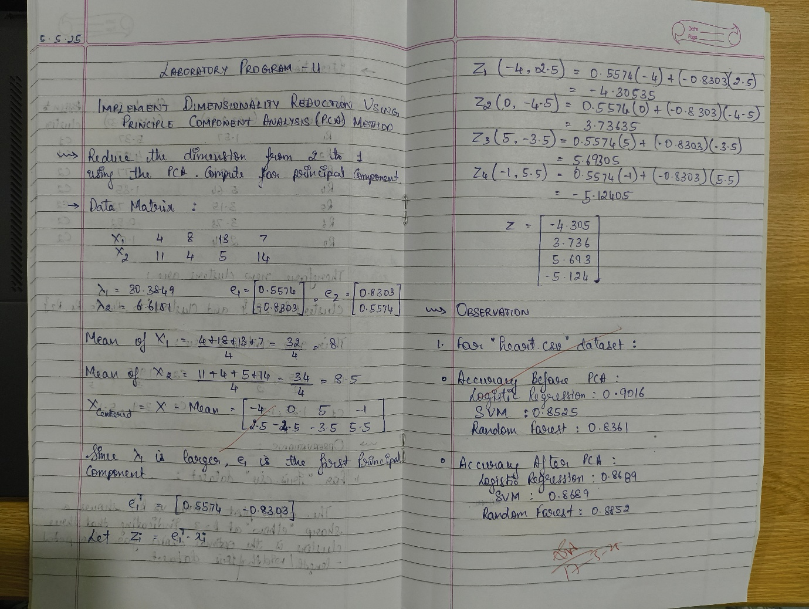

**CODE WITH OUTPUT**

import pandas as pd

df = pd.read_csv("heart.csv")

*# Step 3: Split Features and Target*

X = df.drop("target", axis=1)

y = df["target"]

*# Step 4: Preprocessing*

from sklearn.model_selection import train_test_split

from sklearn.preprocessing import StandardScaler, OneHotEncoder

from sklearn.compose import ColumnTransformer

from sklearn.pipeline import Pipeline

categorical_features = ["cp", "thal", "slope"]

numerical_features = [col for col in X.columns if col not in categorical_features]

preprocessor = ColumnTransformer(transformers=[

("num", StandardScaler(), numerical_features),

("cat", OneHotEncoder(), categorical_features)

])

*# Step 5: Train/Test Split*

X_train, X_test, y_train, y_test = train_test_split(X, y, test_size=0.2, random_state=42)

*# Step 6: Models*

from sklearn.linear_model import LogisticRegression

from sklearn.svm import SVC

from sklearn.ensemble import RandomForestClassifier

from sklearn.metrics import accuracy_score

models = {

"Logistic Regression": LogisticRegression(max_iter=1000),

"SVM": SVC(),

"Random Forest": RandomForestClassifier()

}

*# Step 7: Train and Evaluate Models (Before PCA)*

print("Accuracy Before PCA:")

results = {}

for name, model in models.items():

pipeline = Pipeline(steps=[

("preprocessor", preprocessor),

("classifier", model)

])

pipeline.fit(X_train, y_train)

y_pred = pipeline.predict(X_test)

acc = accuracy_score(y_test, y_pred)

results[name] = acc

print(f"{name}: {acc:.4f}")

from sklearn.decomposition import PCA

print("\nAccuracy After PCA (n_components=5):")

pca_results = {}

for name, model in models.items():

pipeline_pca = Pipeline(steps=[

("preprocessor", preprocessor),

("pca", PCA(n_components=5)),

("classifier", model)

])

pipeline_pca.fit(X_train, y_train)

y_pred_pca = pipeline_pca.predict(X_test)

acc_pca = accuracy_score(y_test, y_pred_pca)

pca_results[name] = acc_pca

print(f"{name}: {acc_pca:.4f}")

